SEMESTER 1
INTRODUCTION TO MICROCONTROLLERS: ARDUINO AND ESP32
Architecture | Digital Inputs and Outputs | PWM and Actuator Control | UART Communication


Module Overview
This module builds a complete, practical foundation in microcontrollers — starting with what a microcontroller is and how the Arduino Uno and ESP32 are built inside, then progressing through digital outputs, digital inputs, Pulse-Width Modulation (PWM) for actuator control, and UART serial communication. Every topic is taught on both boards side by side, so learners understand the difference between a 5 V, 8-bit AVR controller and a 3.3 V, 32-bit dual-core ESP32 rather than memorising one board's tricks.
Each section ends with hands-on lab exercises, and every lab contributes one working component to the module project, GateKeeper: a two-board smart parking gate in which an Arduino Uno senses cars and moves a barrier while an ESP32 controller counts occupancy, drives a ventilation fan and supervises the link between them. Labs start in the free Wokwi simulator and then move to real hardware. Taught end-to-end, the full set of topics is designed to fill approximately 40–45 hours of instruction and practice.
# | Topic | Hands-on Focus
1 | Introduction to Microcontrollers & Embedded Systems | Lab: Blink and print from Uno and ESP32
2 | Arduino and ESP32 Architecture | Lab: Board ID card and speed benchmark
3 | Digital Outputs | Lab: Non-blocking traffic light
4 | Digital Inputs | Lab: Debounced vehicle counter with interrupt
5 | PWM and Actuator Control | Labs: LED fade, servo barrier, DC motor
6 | UART Communication Interface | Labs: Command parser, Uno–ESP32 link
7 | Module Project: GateKeeper Smart Parking Gate | Lab: Integrate, test and document

Learning Outcomes
By the end of this module, learners will be able to:
- Explain what a microcontroller is, how it differs from a microprocessor, and identify its CPU, memory, clock, GPIO and peripherals.
- Compare the Arduino Uno (AVR) and ESP32 architectures and select a suitable board for a stated requirement.
- Configure Arduino IDE 2, the ESP32 board package and Wokwi, and upload and debug sketches on both boards.
- Build digital output circuits with correctly calculated resistors and drivers, controlled by non-blocking timing and state machines.
- Implement reliable digital inputs using pull-ups, debouncing, edge detection and interrupts.
- Generate PWM at a specified frequency, duty cycle and resolution to control an LED, a servo and a DC motor.
- Implement UART links between a PC and a board and between two boards, with level shifting and a checksummed message protocol.
- Diagnose hardware and firmware faults with serial logs, a multimeter and a logic analyzer.
- Integrate, test and document a two-board embedded system as a portfolio project.

Hardware and Software Required
Item | Purpose
Arduino Uno R3 (or Uno R4 Minima) | 5 V reference board
ESP32 DevKitC (ESP32-WROOM-32) | 3.3 V, 32-bit dual-core board with Wi-Fi/BLE
Breadboard, jumper wires, LEDs, 220 Ω / 330 Ω / 1 kΩ / 2 kΩ / 10 kΩ resistors, push buttons | Core circuits
SG90 micro servo, small DC motor, TB6612FNG driver, passive buzzer, IR break-beam or IR obstacle sensor | Actuators and sensors
4 × AA battery pack (6 V) | Separate supply for servo and motor
Digital multimeter, 8-channel USB logic analyzer | Measuring and viewing signals
Arduino IDE 2.x, Arduino-ESP32 core 3.x, Wokwi simulator, PulseView | Software (all free)

1. Introduction to Microcontrollers & Embedded Systems

1.1 What Is an Embedded System?
An embedded system is a small computer hidden inside a product and dedicated to one job. It reads inputs such as buttons and sensors, processes them with a program stored in its memory, and drives outputs such as lights, motors, displays and messages to other devices. Unlike a laptop, it usually runs without an operating system, starts in a fraction of a second, and keeps running for years.
Embedded systems are everywhere: washing machines, car airbag controllers, smart meters, drones, fitness bands and medical pumps all contain at least one. A useful habit for every engineer is to describe any device as Input → Processing → Output (I-P-O).
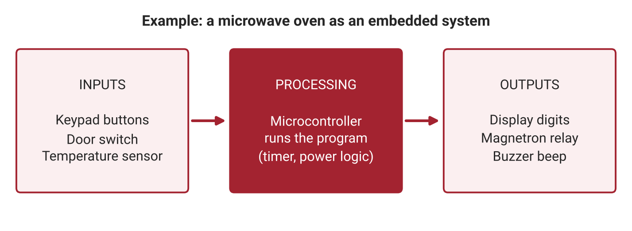
Figure 1.1: A microwave oven described as Input → Processing → Output, the basic model of every embedded system.

1.2 Microcontroller vs Microprocessor
A microcontroller (MCU) places the CPU, flash memory (program storage), SRAM (working memory) and peripherals (GPIO, timers, UART, ADC) on a single chip. A microprocessor (MPU), such as the processor on a Raspberry Pi, is only the CPU; it needs external RAM, storage and power-management chips and normally runs an operating system.
Feature | Microcontroller (e.g., ATmega328P, ESP32) | Microprocessor (e.g., Raspberry Pi SoC)
Memory and peripherals | On the same chip | External chips required
Start-up time | Milliseconds | Tens of seconds (OS boot)
Power use | Milliwatts; can sleep for months on batteries | Watts
Timing | Predictable, real-time | OS can pause your program
Best for | Controlling hardware, sensors, motors | Screens, cameras, heavy computing, networking stacks

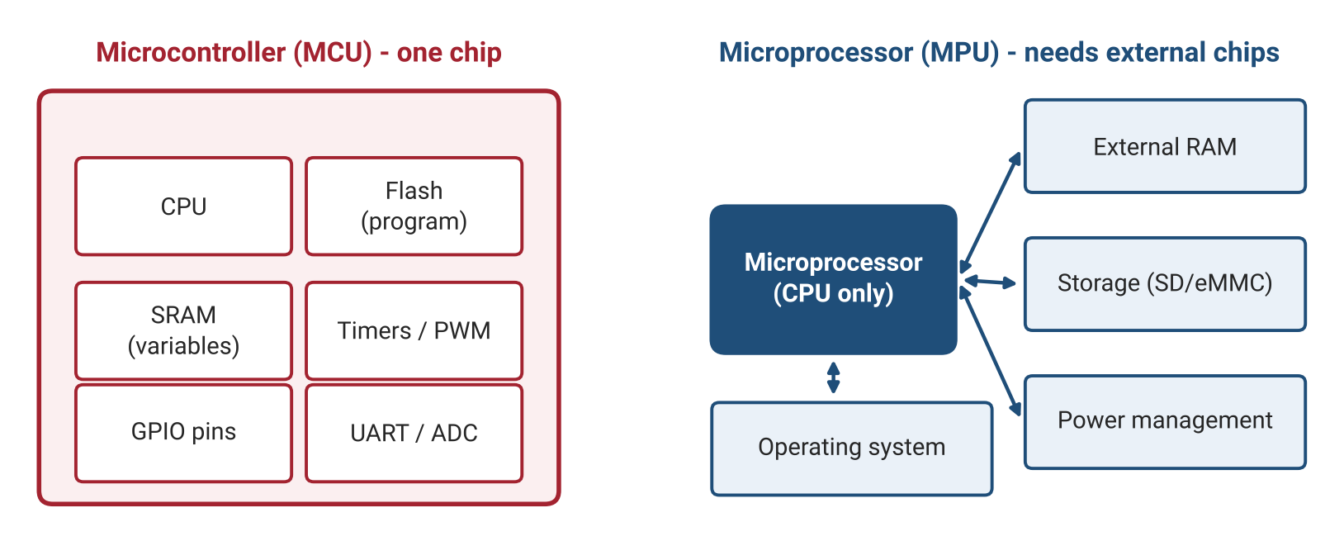
Figure 1.2: A microcontroller integrates everything on one chip; a microprocessor relies on external memory, storage and an operating system.

1.3 Arduino and ESP32: The Two Boards in This Module
Arduino is a board and software ecosystem; the black chip on the Arduino Uno is the actual microcontroller, the ATmega328P. ESP32 is a family of microcontrollers from Espressif; the ESP32 DevKitC board places an ESP32-WROOM-32 module on a breadboard-friendly board with USB. Both are programmed with the same Arduino language (C++) and the same IDE, which makes them ideal for comparing two very different architectures.

1.4 The Toolchain: From Code to a Running Board
Programs for these boards are called sketches. The Arduino IDE compiles the C++ sketch into machine code for the selected chip and uploads it over USB, where a small program already on the chip, the bootloader, writes it into flash memory. Every sketch has two functions: setup(), which runs once at power-on, and loop(), which runs forever.
- Install Arduino IDE 2.x and select Tools → Board → Arduino Uno.
- Add ESP32 support: File → Preferences → Additional boards manager URLs: https://espressif.github.io/arduino-esp32/package_esp32_index.json, then install esp32 by Espressif Systems (version 3.x) from the Boards Manager.
- Use Wokwi (wokwi.com) to simulate both boards in the browser before touching hardware.
- Serial.begin(115200) opens a text channel to the PC; open Tools → Serial Monitor and set the same baud rate.
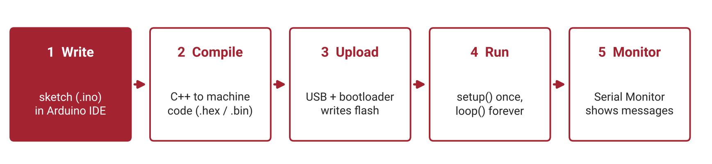
Figure 1.3: The five steps from writing a sketch to seeing its output in the Serial Monitor.

1.5 Common Mistakes to Avoid
- Using a charge-only USB cable — no serial port appears in the IDE.
- Selecting the wrong board or port before uploading.
- Serial Monitor baud rate not matching Serial.begin() — the text appears as random symbols.
- Missing USB driver (CP210x or CH340) for some ESP32 boards; on some boards, hold BOOT while the IDE shows "Connecting…".
Lab Exercise 1: Blink and Hello on Arduino Uno and ESP32
Objective
To set up the Arduino toolchain for both boards, upload a first sketch that blinks the on-board LED, and print messages to the Serial Monitor, first in the Wokwi simulator and then on real hardware.
Hardware Required
- Arduino Uno R3 and USB cable
- ESP32 DevKitC and USB cable
Software Required
- Arduino IDE 2.x with Arduino-ESP32 core 3.x
- Wokwi simulator (browser)
Working Principle
pinMode() configures the LED pin as an output, and digitalWrite() switches it between HIGH (supply voltage) and LOW (0 V). delay(500) pauses for half a second between changes, producing a 1 Hz blink. Serial.println() sends text over the USB serial link to the PC, where the Serial Monitor displays it. A compile-time check (#if defined(ARDUINO_ARCH_ESP32)) lets the same sketch choose the correct LED pin on either board.
Procedure
- Open Wokwi, create a new Arduino Uno project and paste the program below.
- Start the simulation and confirm that the on-board LED blinks and the Serial Monitor prints the messages.
- Repeat in Wokwi with an ESP32 DevKitC project.
- Connect the Arduino Uno to the PC, select Arduino Uno and the correct port, and click Upload.
- Open the Serial Monitor at 115200 baud and verify the output.
- Select ESP32 Dev Module, connect the ESP32, upload the same sketch and verify again.
- Modify the program to blink an SOS pattern (three short, three long, three short) and print each letter.
Program Code
// Lab 1: Blink + Hello. Works on Arduino Uno and ESP32.
#if defined(ARDUINO_ARCH_ESP32)
const int LED_PIN = 2; // on-board LED on most ESP32 DevKitC boards
#else
const int LED_PIN = LED_BUILTIN; // pin 13 on Arduino Uno
#endif

void setup() {
pinMode(LED_PIN, OUTPUT);
Serial.begin(115200);
Serial.println("Hello from my first microcontroller!");
}

void loop() {
digitalWrite(LED_PIN, HIGH);
Serial.println("LED ON");
delay(500);
digitalWrite(LED_PIN, LOW);
Serial.println("LED OFF");
delay(500);
}

Expected Output
The on-board LED of each board blinks once per second, and the Serial Monitor shows "Hello from my first microcontroller!" followed by alternating "LED ON" and "LED OFF" lines.
Observation
Record what you measure and see while running the experiment. Fill in the table below and attach screenshots of the Serial Monitor (and logic-analyzer captures where asked).
# | What to observe | Your observation
1 | Port name shown for the Uno and for the ESP32
2 | Time taken to compile and upload on each board
3 | Serial Monitor output with the correct baud rate
4 | Serial Monitor output with a wrong baud rate (e.g., 9600)

Conclusion
This activity establishes a working toolchain for both architectures and demonstrates the basic structure of every sketch: one-time configuration in setup() and repeated behaviour in loop(), with the Serial Monitor as the main debugging window.

2. Arduino and ESP32 Architecture

2.1 Inside the Chip
Every microcontroller contains the same core building blocks. The CPU executes instructions one clock tick at a time. Flash memory holds the program and keeps it when power is removed. SRAM holds variables and is wiped at every reset. EEPROM (Uno) or NVS (ESP32) stores small settings permanently. The clock sets the pace (16 MHz on the Uno, up to 240 MHz on the ESP32). Peripherals — GPIO, timers, UART, ADC and the interrupt controller — are hardware blocks that work alongside the CPU and are configured by writing bits into registers.
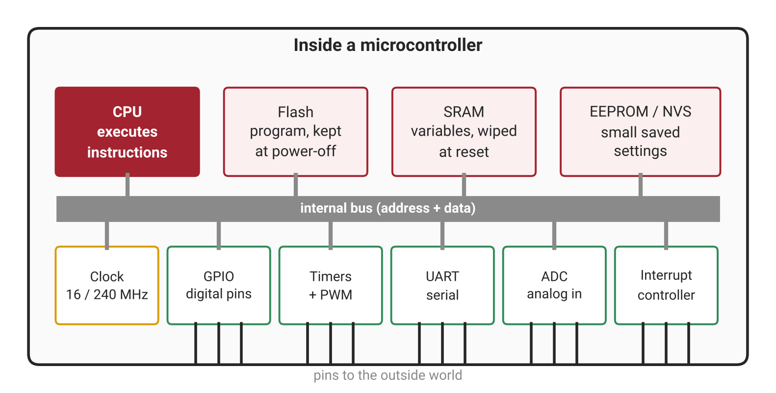
Figure 2.1: Main building blocks inside a microcontroller, connected by an internal bus.
Functions such as digitalWrite() are friendly wrappers around register writes. On the Uno, for example, PORTB |= (1 << 5); sets pin 13 HIGH directly — exactly what digitalWrite(13, HIGH) does underneath.

2.2 Arduino Uno vs ESP32 Side by Side
Feature | Arduino Uno R3 (ATmega328P) | ESP32 DevKitC (ESP32-WROOM-32)
CPU | 8-bit AVR, 1 core, 16 MHz | 32-bit Xtensa LX6, 2 cores, up to 240 MHz
Flash / SRAM | 32 KB / 2 KB | 4 MB (module) / 520 KB
Logic level | 5 V | 3.3 V (not 5 V tolerant)
Usable GPIO | 20 (14 digital + 6 analog) | About 25 (some restricted)
PWM | 6 pins, 8-bit, fixed ~490 / 980 Hz | 16 LEDC channels, configurable frequency and resolution
Hardware UARTs | 1 (shared with USB) | 3
Wireless | None | Wi-Fi + Bluetooth LE
Strengths | Robust 5 V I/O, simple, huge tutorial base | Speed, memory, connectivity, flexible peripherals

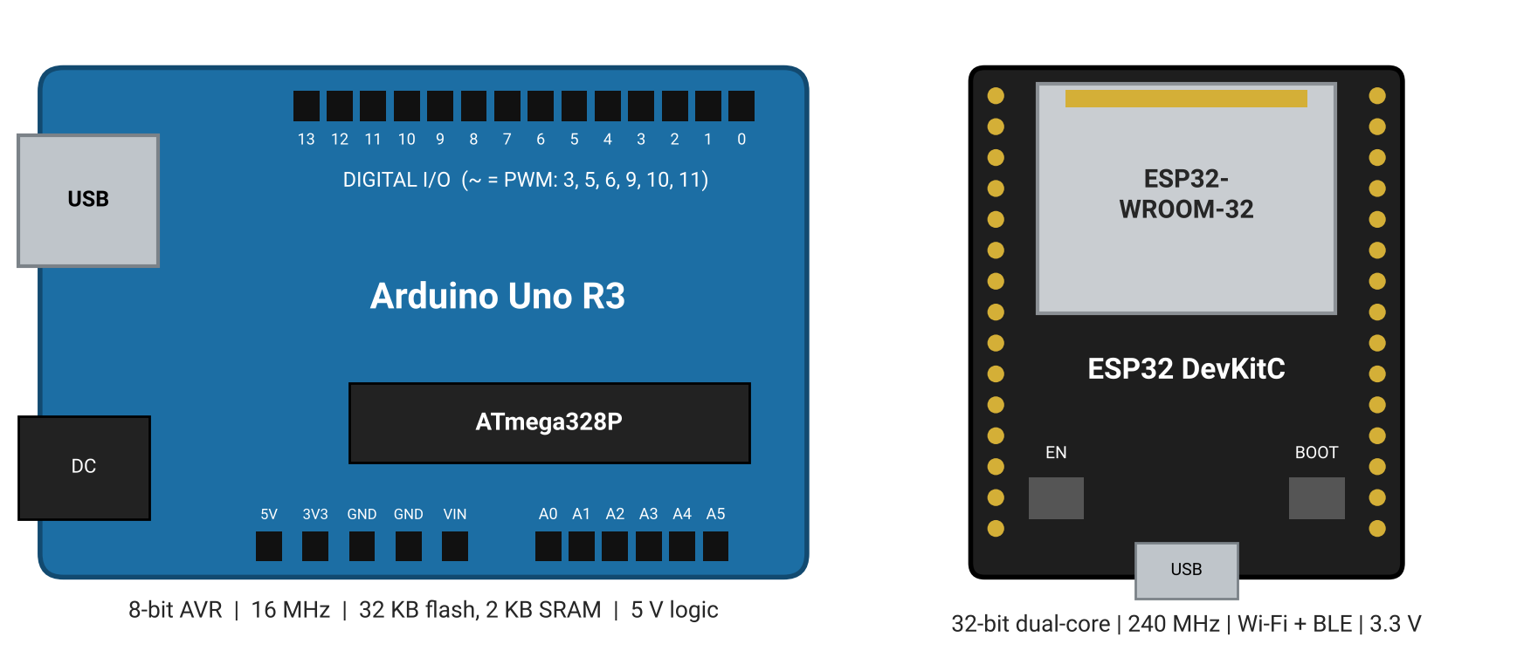
Figure 2.2: Simplified top views of the Arduino Uno R3 and the ESP32 DevKitC with their key specifications.
Newer boards such as the Arduino Uno R4 Minima (Arm Cortex-M4, 48 MHz, 5 V) and the ESP32-S3 and ESP32-C3 (RISC-V) follow the same concepts, so everything in this module transfers directly.

2.3 Pins, Voltages and Boot Pins
A 5 V Uno pin reads HIGH above about 3 V. An ESP32 pin must never see more than 3.6 V, so 5 V signals must be reduced before they reach it (Section 4.4). The ESP32 also has pins with special roles that beginners must respect:
- GPIO 6–11 connect to the internal flash chip — never use them.
- GPIO 0, 2, 5, 12, 15 are strapping pins read at boot; holding them HIGH or LOW during reset can stop the board from starting.
- GPIO 34–39 are input-only and have no internal pull-up resistors.
- On the Uno, pins 0 and 1 carry the USB serial link; using them blocks uploads and the Serial Monitor.
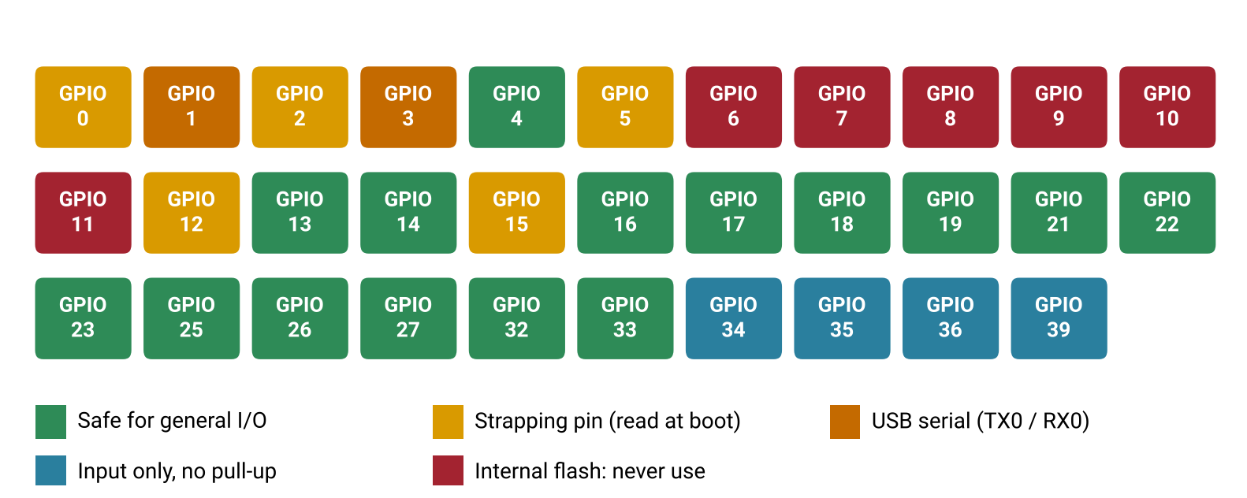
Figure 2.3: ESP32 GPIO safety map: safe pins, strapping pins, USB serial pins, input-only pins and forbidden flash pins.

2.4 What Happens When You Click Upload
The IDE compiles the sketch, links it with the core libraries and produces a binary (.hex for the Uno, .bin for the ESP32). The Uno is reset automatically and its bootloader listens briefly for new code; the ESP32's ROM bootloader is entered through its EN and BOOT lines, which the upload tool controls automatically on most boards. After building, the IDE reports how much flash and SRAM the sketch uses. On the Uno, wrapping fixed text in F("...") keeps it in flash and saves precious SRAM.

2.5 Common Mistakes to Avoid
- Confusing flash with SRAM — "my sketch is only 30% but it crashes" usually means SRAM is full.
- Wiring 5 V sensor outputs directly to ESP32 inputs.
- Using a strapping pin or GPIO 34–39 for a button and getting random behaviour.
- Reading only the last line of an error log instead of the first error.
Lab Exercise 2: Board ID Card and Speed Benchmark
Objective
To read architecture information directly from each microcontroller and compare their computing speed using the same benchmark, linking measured results to the architecture differences studied in this section.
Hardware Required
- Arduino Uno R3
- ESP32 DevKitC
Software Required
- Arduino IDE 2.x
- Wokwi simulator (optional)
Working Principle
Each board family exposes information through its core library: the ESP32 provides functions such as ESP.getChipModel() and ESP.getFreeHeap(), while the AVR core provides the clock constant F_CPU, and free SRAM can be estimated from the gap between the heap and the stack. The benchmark times 100,000 floating-point multiplications with micros(). Differences in clock speed, data width (8-bit vs 32-bit) and the ESP32's hardware floating-point unit produce very different timings.
Procedure
- Open a new sketch and enter the program below.
- Upload it to the Arduino Uno and open the Serial Monitor at 115200 baud.
- Record the board family, clock, free SRAM and benchmark time.
- Upload the same sketch to the ESP32 and record its chip model, cores, CPU frequency, flash size, free heap and benchmark time.
- Calculate how many times faster the ESP32 completed the benchmark.
- Write three sentences explaining the speed difference using architecture terms.
Program Code
// Lab 2: print what this chip is, then time 100,000 float multiplications.
void setup() {
Serial.begin(115200);
delay(1000);
#if defined(ARDUINO_ARCH_ESP32)
Serial.println("Family: ESP32 (32-bit, 3.3 V logic)");
Serial.printf("Model: %s rev %d, cores: %d, CPU: %lu MHz\n",
ESP.getChipModel(), ESP.getChipRevision(),
ESP.getChipCores(), (unsigned long)ESP.getCpuFreqMHz());
Serial.printf("Flash: %lu bytes, free heap: %lu bytes\n",
(unsigned long)ESP.getFlashChipSize(), (unsigned long)ESP.getFreeHeap());
#elif defined(ARDUINO_ARCH_AVR)
Serial.println(F("Family: AVR ATmega328P (8-bit, 5 V logic)"));
Serial.print(F("CPU clock (Hz): ")); Serial.println(F_CPU);
extern int __heap_start, *__brkval;
int v;
int freeRam = (int)&v - (__brkval == 0 ? (int)&__heap_start : (int)__brkval);
Serial.print(F("Free SRAM (bytes): ")); Serial.println(freeRam);
#else
Serial.println("Other architecture");
#endif

volatile float x = 1.0001;
unsigned long t0 = micros();
for (long i = 0; i < 100000; i++) x *= 1.0001;
unsigned long dt = micros() - t0;
Serial.print("100k float multiplies took (us): ");
Serial.println(dt);
}

void loop() {}

Expected Output
Each board prints its own identity card. The ESP32 reports two cores, a CPU frequency of up to 240 MHz and several megabytes of flash, while the Uno reports a 16 MHz clock and less than 2 KB of free SRAM. The ESP32 completes the benchmark many times faster than the Uno.
Observation
Record what you measure and see while running the experiment. Fill in the table below and attach screenshots of the Serial Monitor (and logic-analyzer captures where asked).
# | What to observe | Your observation
1 | Uno: CPU clock and free SRAM
2 | ESP32: chip model, cores, CPU MHz, flash size, free heap
3 | Benchmark time on each board (µs)
4 | Speed ratio ESP32 : Uno

Conclusion
This activity shows that architecture is not abstract: clock rate, bit width and hardware features directly change how much work a board can do, which guides the choice of board in real projects. In the module project, the Uno is used as the robust 5 V field node and the ESP32 as the faster, better-connected controller.

3. Digital Outputs

3.1 GPIO and digitalWrite()
GPIO stands for General-Purpose Input/Output. pinMode(pin, OUTPUT) connects the pin's internal driver; digitalWrite(pin, HIGH) connects the pin to the supply (5 V on the Uno, 3.3 V on the ESP32) and digitalWrite(pin, LOW) connects it to ground. When current flows out of the pin into a load the pin is sourcing current; when current flows from the supply through the load into the pin, it is sinking current.
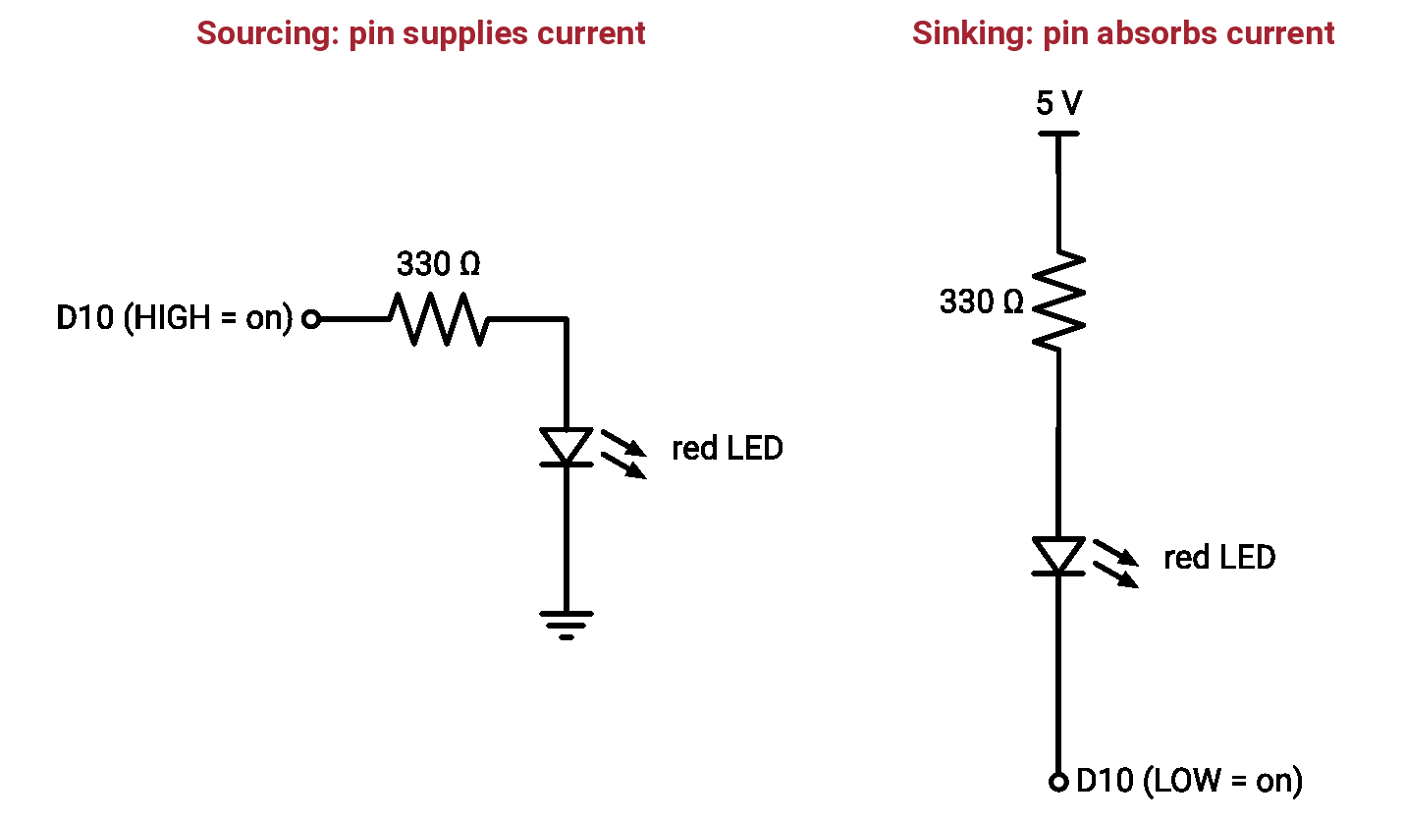
Figure 3.1: Sourcing and sinking connections: in the sinking circuit the LED turns on when the pin is LOW.

3.2 LEDs, Resistors and Current Limits
An LED must always have a series resistor to limit its current. The value comes from Ohm's law: R = (V supply − V LED) ÷ I. A red LED drops about 2.0 V. On the Uno at 10 mA: (5 − 2) ÷ 0.010 = 300 Ω, so the next standard value, 330 Ω, is used. On the ESP32 at 5 mA: (3.3 − 2) ÷ 0.005 = 260 Ω, so 220–330 Ω is suitable.
Limit | Arduino Uno (ATmega328P) | ESP32
Recommended current per pin | 20 mA | about 20 mA (default drive)
Absolute maximum per pin | 40 mA | 40 mA
Total for the package | 200 mA | —

3.3 Driving Bigger Loads with a Transistor
Motors, relays, buzzers and LED strips need more current than a pin can supply. The pin then drives only a small control current into a transistor, which switches the large load current from a separate supply. For an NPN transistor such as the 2N2222, the base resistor is approximately (V pin − 0.7) ÷ I base, with I base about one tenth of the load current. For a 100 mA load on the Uno: (5 − 0.7) ÷ 0.010 = 430 Ω, so 470 Ω is used. Coils such as motors and relays must have a flyback diode across them to absorb the voltage spike when they switch off, and all grounds must be joined.
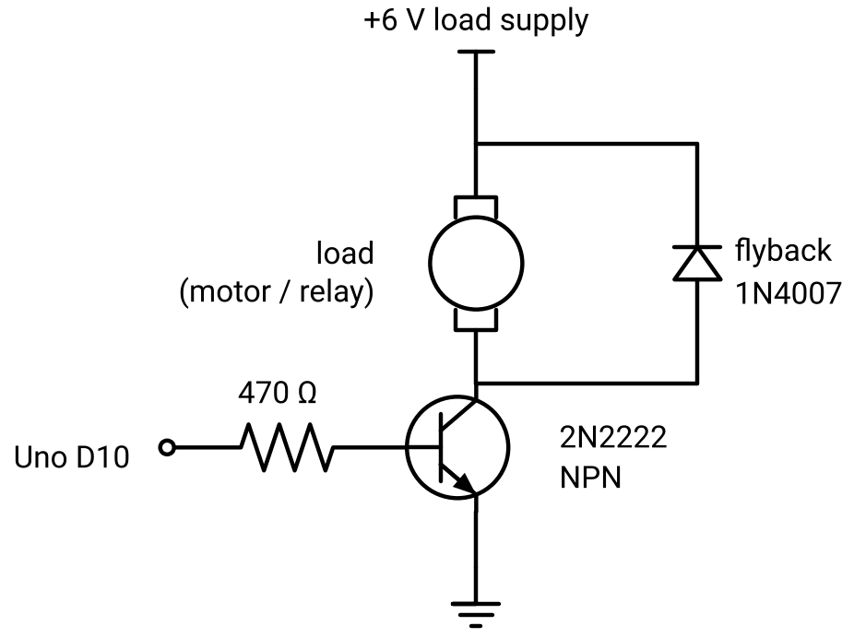
Figure 3.2: NPN transistor driver: the pin controls the base, the transistor switches the load, and the diode absorbs the switch-off spike.

3.4 Non-blocking Time with millis()
delay() freezes the CPU, so while it waits nothing else can happen — a button press may be missed. Real products must sense and act at the same time. millis() returns the number of milliseconds since the board started. Instead of waiting, the program stores when something last happened and, on every pass of loop(), asks whether enough time has passed: if (millis() - last >= interval). Using unsigned long variables keeps this subtraction correct even when millis() wraps around after about 49.7 days.
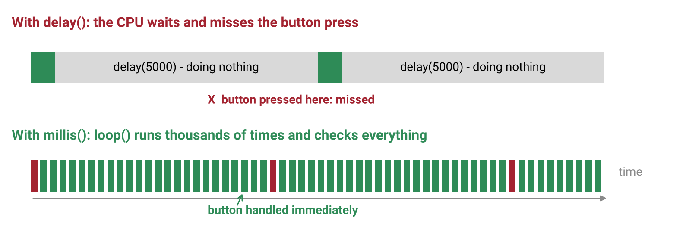
Figure 3.3: With delay() the CPU is blocked and misses events; with millis() loop() keeps running and reacts immediately.
The example below blinks two LEDs at different rates — impossible to do cleanly with delay():
const int LED_A = 10, LED_B = 11; // ESP32: 18, 19
unsigned long lastA = 0, lastB = 0;
bool a = false, b = false;

void setup() { pinMode(LED_A, OUTPUT); pinMode(LED_B, OUTPUT); }

void loop() {
unsigned long now = millis();
if (now - lastA >= 250) { lastA = now; a = !a; digitalWrite(LED_A, a); }
if (now - lastB >= 700) { lastB = now; b = !b; digitalWrite(LED_B, b); }
}

3.5 State Machines
A state machine describes behaviour as a set of states (modes such as RED) and transitions (moving to another state when a condition becomes true, such as 5 seconds elapsing). Each state sets its outputs when it is entered. Drawing the state diagram first and then coding it with an enum and if/switch statements is how industrial controllers, vending machines and communication protocols are written.
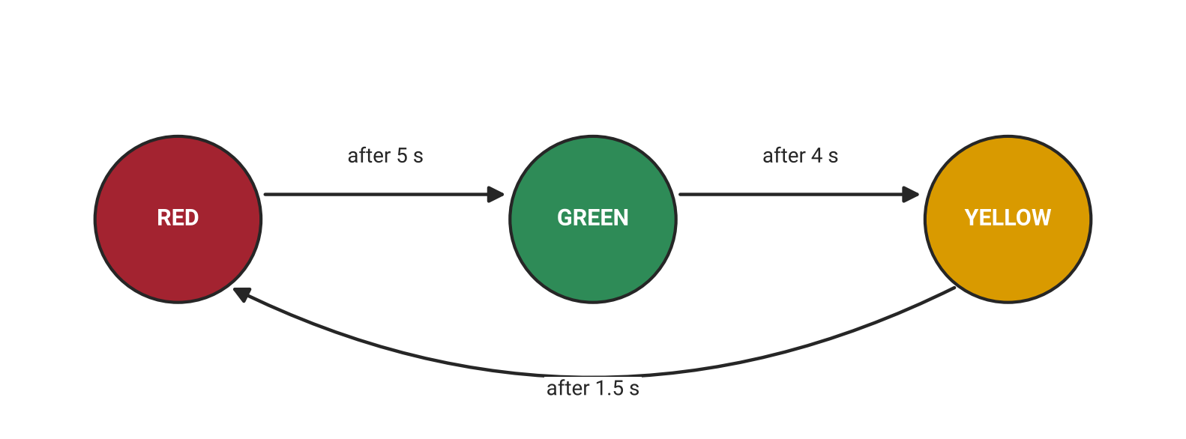
Figure 3.4: Traffic-light state machine with timed transitions.

3.6 Common Mistakes to Avoid
- Forgetting pinMode(pin, OUTPUT) — on the Uno the LED glows dimly through the internal pull-up.
- LED inserted backwards (the longer leg is the anode, +).
- No series resistor, or a total current above the package limit.
- Storing time in an int, or writing millis() > last + interval (breaks at wrap-around).
Lab Exercise 3: Non-blocking Traffic Light
Objective
To build a three-LED traffic light and control it with a non-blocking state machine, forming Component A (the gate lights) of the GateKeeper module project.
Hardware Required
- Arduino Uno R3 (or ESP32 DevKitC)
- Red, yellow and green LEDs
- 3 × 330 Ω resistors
- Breadboard and jumper wires
Software Required
- Arduino IDE 2.x
- Wokwi simulator
Working Principle
Each LED is driven by its own GPIO pin through a 330 Ω current-limiting resistor. The program stores the current state and the time it was entered. Every pass of loop() compares the elapsed time with the duration of the current state and moves to the next state when it is reached. Because loop() never blocks, the same structure can later read sensors and messages while the lights keep running.
Circuit Connections
Component | Arduino Uno pin | ESP32 pin
Red LED (via 330 Ω) | D10 | GPIO 18
Yellow LED (via 330 Ω) | D11 | GPIO 19
Green LED (via 330 Ω) | D12 | GPIO 21
LED cathodes | GND | GND

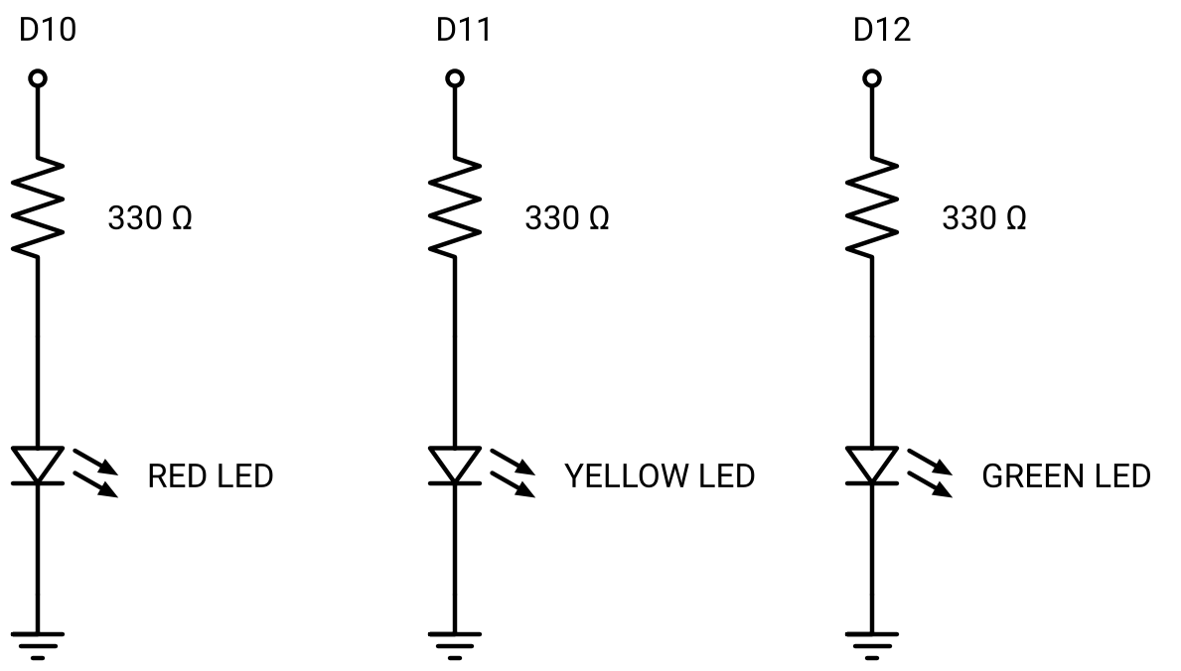
Figure 3.5: Circuit diagram of the traffic-light LEDs
Procedure
- Build the circuit in Wokwi, then on a breadboard, following the connection table.
- Enter the program below and upload it.
- Verify the sequence RED (5 s) → GREEN (4 s) → YELLOW (1.5 s) → RED.
- Open the Serial Monitor and confirm a "State ->" message at every change.
- Add a fourth LED that blinks every 300 ms using millis() without disturbing the traffic light.
- Modify the sketch so that typing o or c in the Serial Monitor forces GREEN or RED (preparation for the module project).
Program Code
// Lab 3: traffic light as a non-blocking state machine.
const int LED_R = 10, LED_Y = 11, LED_G = 12; // ESP32: 18, 19, 21
enum State { S_RED, S_GREEN, S_YELLOW };
State state;
unsigned long stateStart = 0;
const unsigned long DURATION[] = {5000, 4000, 1500}; // ms for RED, GREEN, YELLOW

void lights(bool r, bool y, bool g) {
digitalWrite(LED_R, r); digitalWrite(LED_Y, y); digitalWrite(LED_G, g);
}

void enterState(State s) {
state = s;
stateStart = millis();
if (s == S_RED) lights(HIGH, LOW, LOW);
if (s == S_GREEN) lights(LOW, LOW, HIGH);
if (s == S_YELLOW) lights(LOW, HIGH, LOW);
Serial.print("State -> "); Serial.println(s);
}

void setup() {
Serial.begin(115200);
pinMode(LED_R, OUTPUT); pinMode(LED_Y, OUTPUT); pinMode(LED_G, OUTPUT);
enterState(S_RED);
}

void loop() {
if (millis() - stateStart >= DURATION[state]) {
if (state == S_RED) enterState(S_GREEN);
else if (state == S_GREEN) enterState(S_YELLOW);
else enterState(S_RED);
}
// loop() stays free: inputs and messages plug in here later
}

Expected Output
The LEDs follow the traffic-light sequence with the specified durations, and the Serial Monitor prints the new state number at every transition. The extra blinking LED runs at its own rate without affecting the sequence.
Observation
Record what you measure and see while running the experiment. Fill in the table below and attach screenshots of the Serial Monitor (and logic-analyzer captures where asked).
# | What to observe | Your observation
1 | Measured duration of each state (use a stopwatch)
2 | Serial Monitor messages at each transition
3 | Current through one LED measured with a multimeter (mA)
4 | Behaviour of the extra 300 ms LED

Conclusion
This activity demonstrates safe LED driving with calculated resistors and the two habits that separate professional firmware from beginner code: non-blocking timing and state machines.

4. Digital Inputs

4.1 Reading Pins, Floating Inputs and Pull-ups
pinMode(pin, INPUT) turns a pin into a listener and digitalRead(pin) returns HIGH or LOW. If nothing drives the pin it floats and picks up electrical noise, returning random values. A pull-up resistor (often 10 kΩ) holds the pin HIGH until a button connects it to ground. Both boards contain built-in pull-ups enabled with INPUT_PULLUP; the ESP32 also offers INPUT_PULLDOWN. With a pull-up, a pressed button reads LOW — this is called active-low logic.
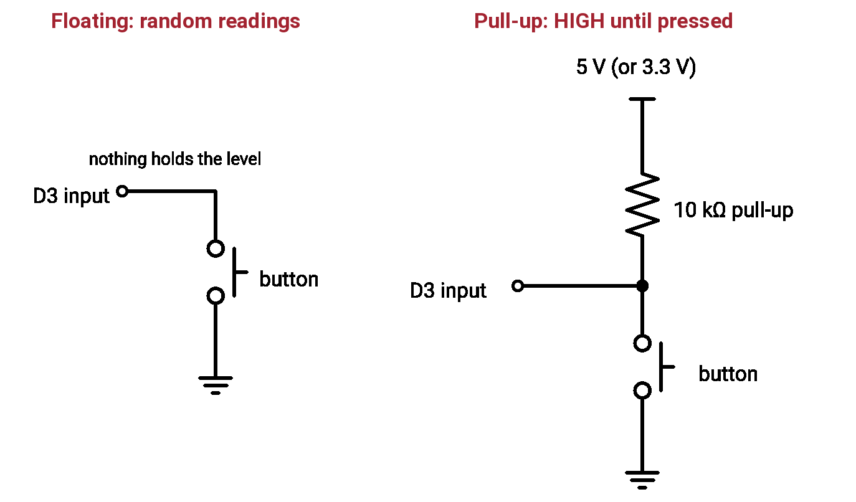
Figure 4.1: A floating input reads random values; a pull-up resistor holds the pin HIGH until the button pulls it LOW.

4.2 Debouncing and Edge Detection
Mechanical contacts bounce: a single press can switch the signal 5–20 times within a few milliseconds, causing double counts. Debouncing accepts a new level only after it has stayed stable for a set time (typically 20–50 ms). Edge detection acts on the change from HIGH to LOW (a falling edge) rather than on the level, so holding a button down does not repeat the action.
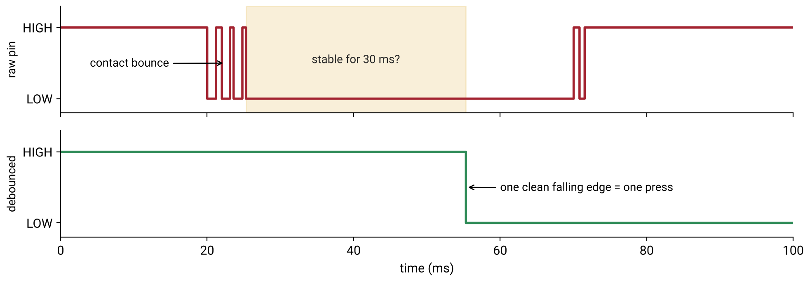
Figure 4.2: Contact bounce on the raw pin and the single clean edge produced by debouncing.
const int BTN = 3, LED = 13; // ESP32: 4, 2
const unsigned long DEBOUNCE_MS = 30;
int stableState = HIGH, lastReading = HIGH;
unsigned long lastChange = 0;
bool ledOn = false;

void setup() { pinMode(BTN, INPUT_PULLUP); pinMode(LED, OUTPUT); Serial.begin(115200); }

void loop() {
int reading = digitalRead(BTN);
if (reading != lastReading) { lastChange = millis(); lastReading = reading; }
if (millis() - lastChange > DEBOUNCE_MS && reading != stableState) {
stableState = reading;
if (stableState == LOW) { // falling edge = press (active-low)
ledOn = !ledOn;
digitalWrite(LED, ledOn);
Serial.println("PRESS");
}
}
}

4.3 Interrupts
Polling a pin in loop() can miss pulses shorter than one pass through the loop. An interrupt pauses the main program the moment a pin changes and runs a short function called an ISR (Interrupt Service Routine). ISRs must be very short, must not use Serial or delay(), and any variable shared with the main program must be declared volatile. On the Uno, external interrupts are available only on D2 and D3; on the ESP32 any GPIO can be used, and the ISR should be marked IRAM_ATTR.

4.4 Digital Sensors and 5 V-to-3.3 V Safety
Many sensors behave exactly like a button: IR break-beam receivers, IR obstacle modules, PIR motion sensors, reed switches and limit switches all produce a HIGH or LOW signal. Sensors with an open-collector output only pull the line LOW, so a pull-up to 3.3 V makes them safe for the ESP32. A sensor with a 5 V push-pull output needs a voltage divider (1 kΩ over 2 kΩ gives 5 × 2 ÷ 3 = 3.33 V) or a level-shifter module.
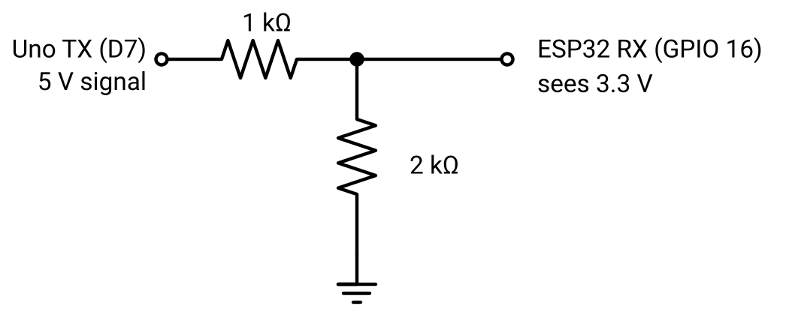
Figure 4.3: A 1 kΩ / 2 kΩ voltage divider reduces a 5 V signal to a safe 3.3 V for the ESP32.

4.5 Common Mistakes to Avoid
- Button wired to 5 V with no pull-down resistor (floating input).
- Expecting pressed = HIGH when using INPUT_PULLUP.
- Using delay(50) for debouncing, which freezes everything else.
- Printing inside an ISR, forgetting volatile, or using an Uno pin other than D2/D3 for an interrupt.
- Sensor ground not connected to the board ground.
Lab Exercise 4: Debounced Vehicle Counter with Interrupt
Objective
To count vehicles passing an IR beam using a hardware interrupt with software debouncing, and to add a debounced manual button, forming Component B (car sensing) of the GateKeeper project.
Hardware Required
- Arduino Uno R3 (or ESP32 DevKitC)
- IR break-beam sensor or IR obstacle-avoidance module
- Push button
- Breadboard and jumper wires
Software Required
- Arduino IDE 2.x
- Wokwi simulator (use a push button to simulate the sensor)
Working Principle
The sensor output is connected to an interrupt-capable pin with the internal pull-up enabled; when a car breaks the beam, the output falls LOW and triggers the ISR on the falling edge. The ISR ignores any further edge within 50 ms, filtering bounce and electrical noise, and increments a volatile counter. Once per second the main loop copies the counter safely and prints it.
Circuit Connections
Component | Arduino Uno | ESP32
Sensor VCC | 5V | 3V3 (or 5V with a divider on OUT)
Sensor OUT | D2 (interrupt) | GPIO 4
Push button | D3 to GND | GPIO 14 to GND
Sensor GND / button GND | GND | GND

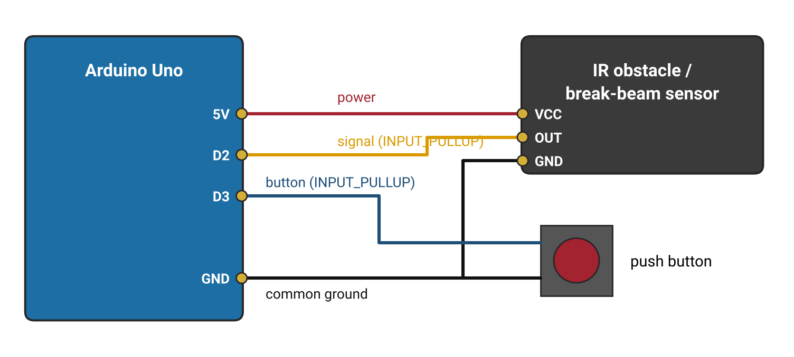
Figure 4.4: Wiring of the IR sensor and push button to the Arduino Uno
Procedure
- Connect the sensor and button as shown in the connection table.
- Upload the program below and open the Serial Monitor at 115200 baud.
- Pass a hand or card through the beam ten times and compare the count with the true number.
- Change the lockout from 50000 to 0 microseconds and repeat; note any double counts.
- Restore the lockout and add the debounced button code from Section 4.2 so that each press prints "EVT:EXIT".
- Make each beam break print "EVT:ARRIVE" as well as updating the count.
Program Code
// Lab 4: count beam breaks with an interrupt, report once per second.
#if defined(ARDUINO_ARCH_ESP32)
const int SENSOR = 4; // any GPIO on ESP32
#define ISR_ATTR IRAM_ATTR
#else
const int SENSOR = 2; // Uno: external interrupts on D2 or D3 only
#define ISR_ATTR
#endif

volatile unsigned long count = 0;
volatile unsigned long lastIsrUs = 0;

void ISR_ATTR onBeamBroken() {
unsigned long now = micros();
if (now - lastIsrUs > 50000UL) { // 50 ms lockout ignores bounce and noise
count++;
lastIsrUs = now;
}
}

void setup() {
Serial.begin(115200);
pinMode(SENSOR, INPUT_PULLUP);
attachInterrupt(digitalPinToInterrupt(SENSOR), onBeamBroken, FALLING);
}

void loop() {
static unsigned long lastPrint = 0;
if (millis() - lastPrint >= 1000) {
lastPrint = millis();
noInterrupts(); // atomic copy (needed on 8-bit AVR)
unsigned long n = count;
interrupts();
Serial.print("Vehicles: ");
Serial.println(n);
}
}

Expected Output
The Serial Monitor prints the vehicle count once per second. Each beam break increases the count by exactly one; removing the lockout causes extra counts from bounce or noise. Each button press produces a single "EVT:EXIT" message.
Observation
Record what you measure and see while running the experiment. Fill in the table below and attach screenshots of the Serial Monitor (and logic-analyzer captures where asked).
# | What to observe | Your observation
1 | Count after 10 deliberate beam breaks (with lockout)
2 | Count after 10 beam breaks (lockout removed)
3 | Sensor output voltage when clear and when blocked (multimeter)
4 | Number of messages printed for one long button press

Conclusion
This activity shows how pull-ups, debouncing, edge detection and interrupts turn noisy real-world signals into exactly one reliable event per action — the foundation of every sensing system.

5. PWM and Actuator Control

5.1 PWM: Duty Cycle, Frequency and Resolution
A digital pin only knows HIGH and LOW. Pulse-Width Modulation (PWM) switches it on and off very quickly to control average power. The duty cycle is the fraction of each period that the pin is HIGH; the average voltage is approximately duty × supply (50% of 5 V ≈ 2.5 V). The frequency is the number of pulses per second: LEDs need well above 100 Hz to avoid flicker, motors run quietly at about 20 kHz, and hobby servos need exactly 50 Hz. The resolution is the number of duty steps: 8-bit gives 0–255, 10-bit gives 0–1023.
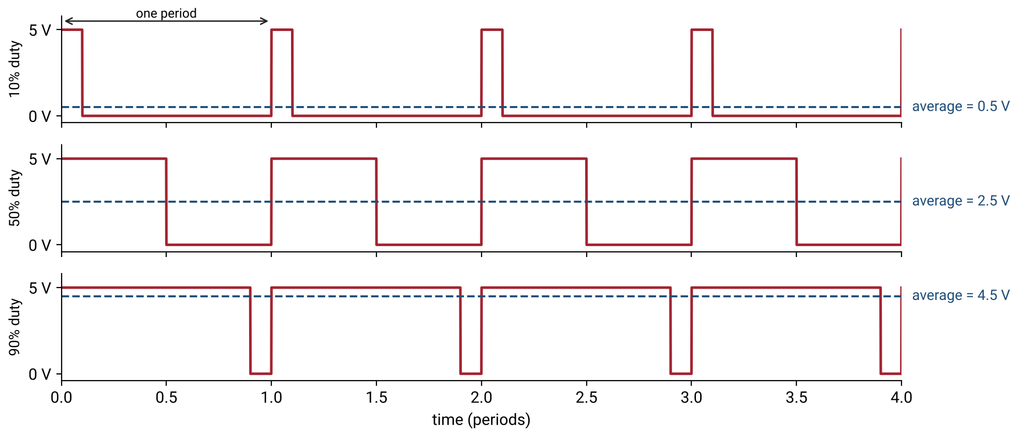
Figure 5.1: PWM signals at 10%, 50% and 90% duty cycle and the average voltage each produces.

5.2 PWM on the Uno vs the ESP32 (LEDC)
Feature | Arduino Uno | ESP32 (Arduino-ESP32 core 3.x)
Function | analogWrite(pin, 0–255) | ledcAttach(pin, freq, bits) then ledcWrite(pin, duty)
Pins | 3, 5, 6, 9, 10, 11 only (marked ~) | Almost any output pin, 16 channels
Frequency | Fixed: ~490 Hz (980 Hz on pins 5, 6) | Configurable (e.g., 50 Hz, 5 kHz, 20 kHz)
Resolution | 8-bit | Configurable, e.g., 8 to 14 bits

Many older ESP32 tutorials use ledcSetup() and ledcAttachPin(); these belonged to the 2.x core and no longer compile on core 3.x. On the Uno, the Servo library takes over Timer 1, which disables analogWrite() on pins 9 and 10.

5.3 Servo Control
A hobby servo reads one pulse every 20 ms (50 Hz). The width of the pulse sets the angle: about 1.0 ms for 0°, 1.5 ms for 90° and 2.0 ms for 180° (SG90 servos often span 0.5–2.4 ms). The Uno uses the built-in Servo library and the ESP32 uses the ESP32Servo library, which offers the same attach() and write() functions. Servos draw 100–700 mA when moving, so they should be powered from a separate 5–6 V supply with grounds joined.
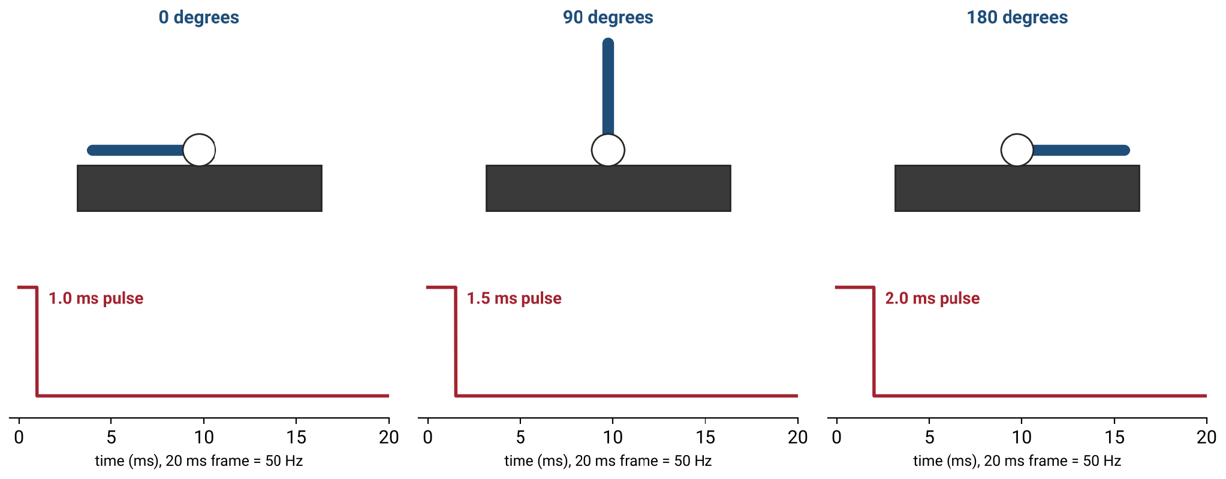
Figure 5.2: Servo position is set by the pulse width inside each 20 ms frame.

5.4 DC Motors, H-Bridges and Power
A DC motor needs far more current than a pin can provide, and reversing it requires current to flow both ways. An H-bridge — four electronic switches arranged in an H — solves both problems. The TB6612FNG driver used in this module (preferred over the older, less efficient L298N) uses two direction pins (AIN1, AIN2), one PWM speed pin (PWMA) and a standby pin (STBY). The motor supply (VM) is separate from the logic supply (VCC), and all grounds must be connected.
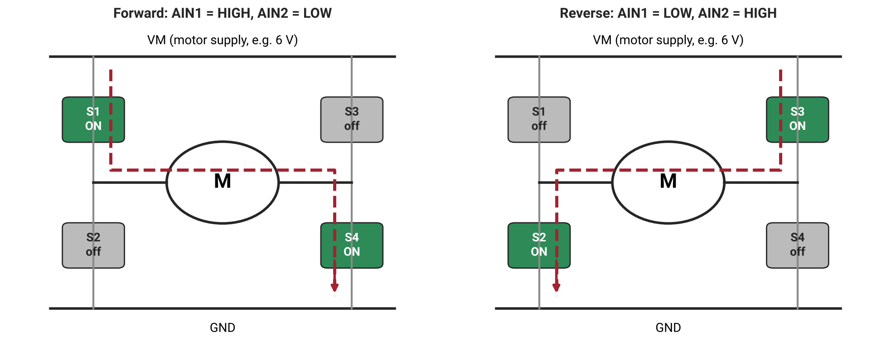
Figure 5.3: H-bridge operation: switching diagonal pairs reverses the current through the motor.

5.5 Common Mistakes to Avoid
- Thinking PWM produces a true analog voltage — the pin is still only 0 V or full supply.
- Using analogWrite() on a non-PWM Uno pin, or copying a 2.x LEDC example onto core 3.x.
- Powering a servo or motor from the board's 5 V pin, causing resets (brown-out).
- Reversing a motor at full speed without stopping first; leaving STBY LOW.
Lab Exercise 5: Measured LED Fade with PWM
Objective
To generate PWM on both boards, fade an LED smoothly, and measure the frequency and duty cycle of the signal using a logic analyzer.
Hardware Required
- Arduino Uno R3 and ESP32 DevKitC
- LED with 330 Ω resistor
- 8-channel USB logic analyzer (or the Wokwi logic analyzer)
Software Required
- Arduino IDE 2.x
- PulseView (or Wokwi logic analyzer export)
Working Principle
On the Uno, analogWrite() produces 8-bit PWM at about 490 Hz on pin 9. On the ESP32, the LEDC peripheral is configured for 5 kHz with 10-bit resolution, giving 1024 brightness steps. The program ramps the duty cycle up and down; a logic analyzer connected to the LED pin displays the actual waveform so that frequency and duty can be measured rather than guessed.
Procedure
- Connect the LED and resistor to Uno pin 9 (ESP32: GPIO 18) and to GND.
- Connect logic-analyzer channel 0 to the same pin and its ground to board GND.
- Upload the program below and observe the fade.
- In PulseView, capture the signal and measure frequency and duty near 10%, 50% and 90% brightness.
- Repeat on the ESP32 and compare frequency and resolution.
- Connect a passive buzzer and play a three-note melody using tone(pin, frequency, duration).
Program Code
// Lab 5: smooth LED fade; capture the pin with a logic analyzer.
#if defined(ARDUINO_ARCH_ESP32)
const int LED = 18;
const int FREQ = 5000, RES = 10; // 5 kHz, 10-bit (0..1023)
const int MAXD = (1 << RES) - 1;
void pwmBegin() { ledcAttach(LED, FREQ, RES); } // Arduino-ESP32 core 3.x API
void pwmWrite(int d) { ledcWrite(LED, d); }
#else
const int LED = 9; // a ~ PWM pin on Uno
const int MAXD = 255; // fixed 8-bit
void pwmBegin() { pinMode(LED, OUTPUT); }
void pwmWrite(int d) { analogWrite(LED, d); }
#endif

void setup() { Serial.begin(115200); pwmBegin(); }

void loop() {
for (int d = 0; d <= MAXD; d += MAXD / 50) { pwmWrite(d); delay(20); }
for (int d = MAXD; d >= 0; d -= MAXD / 50) { pwmWrite(d); delay(20); }
}

Expected Output
The LED fades smoothly up and down on both boards. PulseView shows a square wave of about 490 Hz on the Uno and 5 kHz on the ESP32, with the HIGH time changing as the brightness changes.
Observation
Record what you measure and see while running the experiment. Fill in the table below and attach screenshots of the Serial Monitor (and logic-analyzer captures where asked).
# | What to observe | Your observation
1 | Uno PWM frequency measured (Hz)
2 | ESP32 PWM frequency measured (Hz)
3 | Duty cycle at low, medium and high brightness
4 | Visible difference in fade smoothness (8-bit vs 10-bit)

Conclusion
This activity proves that PWM controls average power by changing duty cycle, and that the ESP32's configurable LEDC peripheral offers far more control over frequency and resolution than the Uno's fixed timers.
Lab Exercise 6: Non-blocking Servo Barrier
Objective
To control a servo motor smoothly and without blocking, so that it opens and closes like a parking barrier on command, forming the barrier part of Component C of the GateKeeper project.
Hardware Required
- Arduino Uno R3 (or ESP32 DevKitC)
- SG90 micro servo
- 4 × AA battery pack (6 V) for the servo
- Jumper wires
Software Required
- Arduino IDE 2.x (Servo library for Uno, ESP32Servo library for ESP32)
- Wokwi simulator
Working Principle
The servo signal pin receives a 50 Hz pulse train whose width sets the angle. Instead of jumping straight to the target, the program moves the servo one degree every 15 ms using millis(), which gives smooth motion and keeps loop() free to read commands. Typing o or c in the Serial Monitor sets the target angle to 90° (open) or 0° (closed).
Circuit Connections
Servo wire | Connection
Signal (orange/yellow) | Uno D9 (ESP32: GPIO 13)
Power (red) | Battery pack + (6 V)
Ground (brown/black) | Battery pack − AND board GND (common ground)

Procedure
- Wire the servo as shown, powering it from the battery pack with grounds joined.
- Upload the program below and open the Serial Monitor (115200 baud).
- Type o and press Enter; observe the barrier opening smoothly. Type c to close it.
- Capture the signal with the logic analyzer and measure the pulse width at 0° and 90°.
- Add an automatic close 3 seconds after opening, using millis().
- Make closing slower than opening by using a different step time.
Program Code
// Lab 6: barrier opens/closes smoothly on 'o' / 'c' from the Serial Monitor.
#if defined(ARDUINO_ARCH_ESP32)
#include <ESP32Servo.h>
const int SERVO_PIN = 13;
#else
#include <Servo.h>
const int SERVO_PIN = 9;
#endif

Servo barrier;
int current = 0, target = 0;
unsigned long lastStep = 0;
const unsigned long STEP_MS = 15; // 1 degree every 15 ms

void setup() {
Serial.begin(115200);
#if defined(ARDUINO_ARCH_ESP32)
barrier.setPeriodHertz(50);
barrier.attach(SERVO_PIN, 500, 2400); // min/max pulse in microseconds
#else
barrier.attach(SERVO_PIN);
#endif
barrier.write(current);
Serial.println("Type o (open) or c (close)");
}

void loop() {
if (Serial.available()) {
char c = Serial.read();
if (c == 'o') target = 90;
if (c == 'c') target = 0;
}
if (current != target && millis() - lastStep >= STEP_MS) {
lastStep = millis();
current += (target > current) ? 1 : -1;
barrier.write(current);
}
}

Expected Output
The servo arm moves smoothly between 0° and 90° on command. The logic analyzer shows a 20 ms period with a pulse of roughly 0.5–1.0 ms at 0° and about 1.5 ms at 90°.
Observation
Record what you measure and see while running the experiment. Fill in the table below and attach screenshots of the Serial Monitor (and logic-analyzer captures where asked).
# | What to observe | Your observation
1 | Pulse width at 0° and at 90° (ms)
2 | Time taken to open fully (s)
3 | Board behaviour when the servo is powered from the board's 5 V pin (instructor demonstration only)
4 | Auto-close timing

Conclusion
This activity demonstrates pulse-width position control and the importance of a separate actuator supply, and it produces the barrier mechanism used in the module project.
Lab Exercise 7: DC Motor Speed and Direction with the TB6612FNG
Objective
To control the speed and direction of a DC motor through an H-bridge driver, forming the ventilation-fan part of Component C of the GateKeeper project.
Hardware Required
- ESP32 DevKitC (or Arduino Uno R3)
- TB6612FNG motor driver module
- Small DC motor (3–6 V)
- 4 × AA battery pack (6 V)
- 100 nF capacitor across the motor terminals (recommended)
Software Required
- Arduino IDE 2.x
Working Principle
AIN1 and AIN2 select the direction (HIGH/LOW for forward, LOW/HIGH for reverse, both LOW to coast), PWMA sets the speed by duty cycle, and STBY must be HIGH to enable the driver. On the ESP32, the PWM frequency is set to 20 kHz, above human hearing, which removes the whining noise heard at the Uno's 490 Hz. The motor draws its current from the battery through VM, never from the board.
Circuit Connections
TB6612FNG pin | ESP32 | Arduino Uno
PWMA | GPIO 25 | D5
AIN1 | GPIO 26 | D7
AIN2 | GPIO 27 | D8
STBY | GPIO 33 | D4
VCC | 3V3 | 5V
VM | Battery + (6 V) | Battery + (6 V)
AO1 / AO2 | Motor terminals | Motor terminals
GND | Board GND and battery − | Board GND and battery −

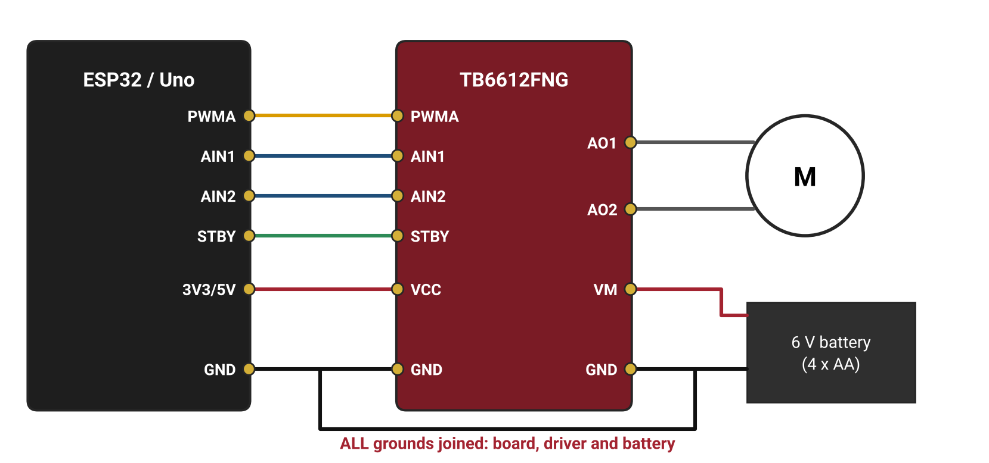
Figure 5.4: Wiring of the TB6612FNG motor driver, DC motor and battery pack
Procedure
- Wire the driver, motor and battery as shown, joining all grounds.
- Upload the program below.
- Observe the motor ramp up forward, stop, ramp up in reverse, and stop.
- Run the same sketch on the Uno and compare the audible noise with the ESP32's 20 kHz PWM.
- Find the minimum duty value at which the motor starts turning and record it.
- Modify the program so that typing a number 0–5 in the Serial Monitor sets the fan speed (preparation for the module project).
Program Code
// Lab 7: speed + direction through a TB6612FNG (channel A).
// VM = 6 V battery, VCC = board logic (3.3 V or 5 V), all GNDs joined.
#if defined(ARDUINO_ARCH_ESP32)
const int PWMA = 25, AIN1 = 26, AIN2 = 27, STBY = 33;
void speedOut(int duty) { ledcWrite(PWMA, duty); }
#else
const int PWMA = 5, AIN1 = 7, AIN2 = 8, STBY = 4;
void speedOut(int duty) { analogWrite(PWMA, duty); }
#endif

void motor(int speed) { // -255 (reverse) .. 255 (forward)
speed = constrain(speed, -255, 255);
digitalWrite(AIN1, speed > 0);
digitalWrite(AIN2, speed < 0); // both LOW = coast
speedOut(abs(speed));
}

void setup() {
pinMode(AIN1, OUTPUT); pinMode(AIN2, OUTPUT); pinMode(STBY, OUTPUT);
#if defined(ARDUINO_ARCH_ESP32)
ledcAttach(PWMA, 20000, 8); // 20 kHz, 8-bit: silent
#else
pinMode(PWMA, OUTPUT);
#endif
digitalWrite(STBY, HIGH); // enable the driver
}

void loop() {
for (int s = 0; s <= 255; s += 5) { motor(s); delay(30); }
delay(1000);
motor(0); delay(500); // stop before reversing
for (int s = 0; s >= -255; s -= 5) { motor(s); delay(30); }
delay(1000);
motor(0); delay(1500);
}

Expected Output
The motor accelerates smoothly forward, pauses, then accelerates in reverse. On the ESP32 the motor runs silently; on the Uno a faint whine is audible. Below a certain duty value the motor stalls and does not turn.
Observation
Record what you measure and see while running the experiment. Fill in the table below and attach screenshots of the Serial Monitor (and logic-analyzer captures where asked).
# | What to observe | Your observation
1 | Minimum duty value at which the motor starts
2 | Audible noise: Uno (490 Hz) vs ESP32 (20 kHz)
3 | Battery voltage at rest and at full speed
4 | Behaviour when STBY is LOW

Conclusion
This activity shows how an H-bridge driver, a separate motor supply and correctly chosen PWM frequency combine to give safe, quiet and controllable motion.

6. UART Communication Interface

6.1 Serial vs Parallel and the UART Frame
Parallel communication sends many bits at once on many wires; serial communication sends them one after another on a single wire. UART (Universal Asynchronous Receiver-Transmitter) is the simplest serial interface. It is asynchronous: there is no shared clock wire, so both sides must agree on the baud rate (bits per second) in advance.
The most common format is 8N1. The line idles HIGH; each byte starts with one start bit (LOW), followed by 8 data bits sent least-significant bit first, no parity bit, and one stop bit (HIGH). At 9600 baud each bit lasts about 104 µs, and because each byte uses 10 bits on the wire, about 960 bytes per second can be sent.
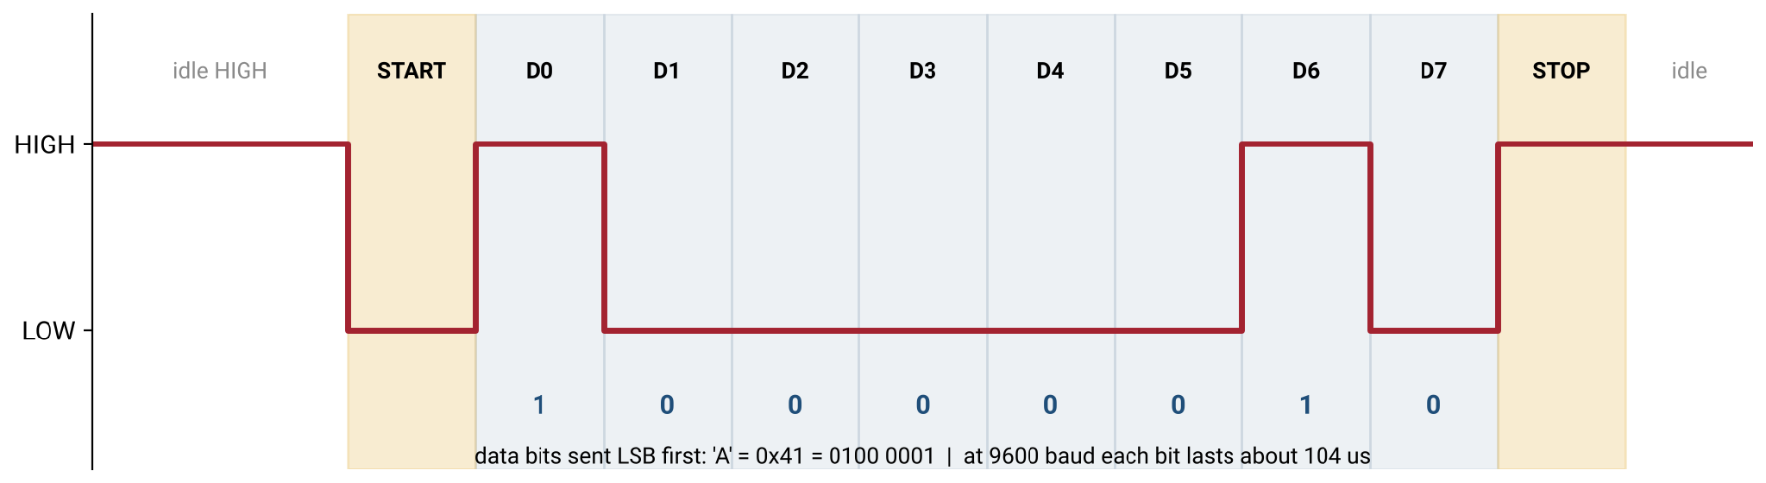
Figure 6.1: The UART frame for the character 'A' (0x41) in 8N1 format.
Wiring is always crossed: TX → RX, RX ← TX, GND ↔ GND. The signals used here are TTL-level (0 V and 3.3 V or 5 V). Old PC RS-232 ports use ± voltages and must never be connected directly to a microcontroller; in factories, UART is often carried over RS-485 for long cables.

6.2 Reading Input Without Blocking
Incoming bytes wait in a receive buffer (64 bytes on the Uno). Serial.available() reports how many bytes are waiting and Serial.read() takes one. Functions such as readString() and parseInt() wait up to one second for more data, which breaks real-time behaviour. The professional approach collects bytes into a fixed character array until a newline character (\n) arrives, and only then processes the complete line. Fixed arrays are preferred over String objects on the Uno's 2 KB of SRAM.

6.3 Designing a Message Protocol
A protocol is an agreement on how messages are built. It defines framing (where a message starts and ends), format (the fields), integrity (a checksum to detect corrupted messages) and liveness (heartbeats and timeouts that detect a broken link). The module project uses a frame inspired by the NMEA sentences sent by GPS modules: PAYLOAD*HH, ended by a newline, where HH is the XOR of all payload characters written as two hexadecimal digits.
Payload | Direction | Meaning | Expected response
EVT:ARRIVE | Uno → ESP32 | Car broke the entry beam | CMD:OPEN if space, else CMD:FULL
EVT:EXIT | Uno → ESP32 | Exit button pressed | CMD:OPEN
CMD:OPEN | ESP32 → Uno | Run one open–hold–close cycle | None
CMD:FULL | ESP32 → Uno | Car park full: beep, stay closed | None
HB:1 | Both, every 2 s | Heartbeat: I am alive | Link declared lost after 5 s of silence

6.4 Board-to-Board Link and Level Shifting
The Uno has only one hardware UART (pins 0 and 1), and it is shared with USB, so the board-to-board link uses SoftwareSerial on D4 (RX) and D7 (TX) at 9600 baud. SoftwareSerial is driven by the CPU itself and briefly pauses interrupts for every byte — a real architectural limitation. The ESP32 has three hardware UARTs; Serial2.begin(9600, SERIAL_8N1, 16, 17) uses GPIO 16 as RX and GPIO 17 as TX. The Uno's 5 V TX signal must pass through the 1 kΩ / 2 kΩ divider before reaching the ESP32; the ESP32's 3.3 V TX signal is read as HIGH by the Uno.
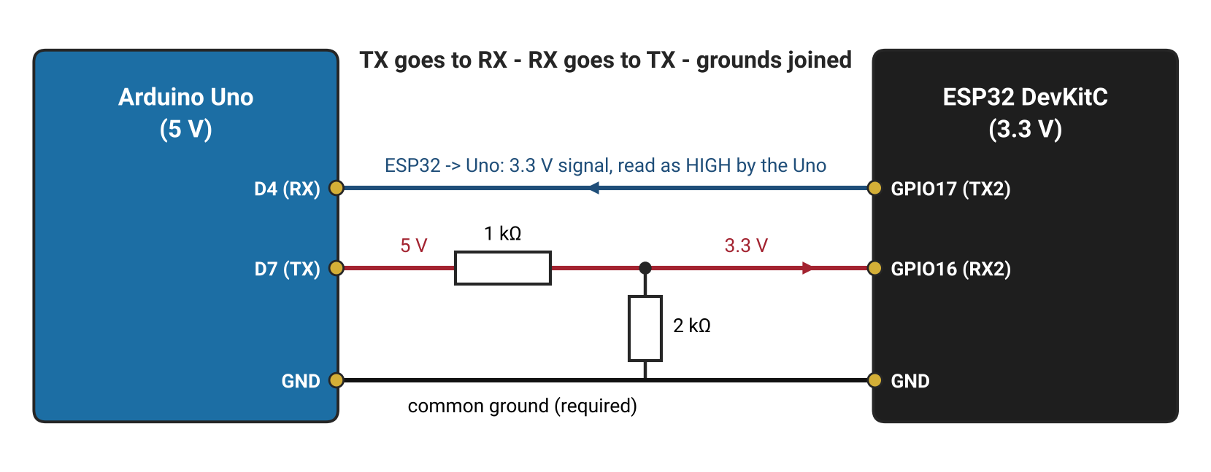
Figure 6.2: UART wiring between the Arduino Uno and the ESP32 with a voltage divider on the Uno's TX line.

6.5 Common Mistakes to Avoid
- Connecting TX to TX, or forgetting the common ground.
- Different baud rates on the two sides (garbled characters).
- Serial Monitor line ending set to "No line ending", so commands never complete.
- Comparing C strings with == instead of strcmp().
- Connecting the Uno's 5 V TX directly to an ESP32 pin.
Lab Exercise 8: Command Parser over USB Serial
Objective
To receive text commands from the PC without blocking, parse them, and control an LED's state and brightness with clear OK/ERROR replies.
Hardware Required
- Arduino Uno R3 (or ESP32 DevKitC)
- LED with 330 Ω resistor
Software Required
- Arduino IDE 2.x (Serial Monitor set to "Newline" and 115200 baud)
Working Principle
readLine() collects incoming characters into a fixed buffer and returns true only when a newline arrives, so loop() never waits. The completed line is compared with known commands using strcmp() and strncmp(). Numbers are extracted with atoi() and checked against the allowed range before use, and every command receives a reply so that the sender always knows the result.
Procedure
- Connect the LED and resistor to Uno pin 9 (ESP32: GPIO 18).
- Upload the program below and open the Serial Monitor with "Newline" selected.
- Send LED:ON, LED:OFF, PWM:30, PWM:200 and observe the LED and replies.
- Send PWM:999 and HELLO and record the error replies.
- Add a STATUS? command that replies with the current brightness.
- Change the line ending to "No line ending" and explain what happens.
Program Code
// Lab 8: non-blocking line parser. Set Serial Monitor to "Newline".
const int LED = 9; // ESP32: 18 (analogWrite works on core 3.x)
const byte MAXLEN = 32;
char line[MAXLEN];
byte len = 0;

bool readLine(Stream &port) {
while (port.available()) {
char c = port.read();
if (c == '\r') continue;
if (c == '\n') { line[len] = '\0'; len = 0; return true; }
if (len < MAXLEN - 1) line[len++] = c;
}
return false;
}

void handle(const char *cmd) {
if (strcmp(cmd, "LED:ON") == 0) { analogWrite(LED, 255); Serial.println("OK"); }
else if (strcmp(cmd, "LED:OFF") == 0) { analogWrite(LED, 0); Serial.println("OK"); }
else if (strncmp(cmd, "PWM:", 4) == 0) {
int v = atoi(cmd + 4);
if (v >= 0 && v <= 255) { analogWrite(LED, v); Serial.println("OK"); }
else Serial.println("ERR:RANGE");
}
else { Serial.print("ERR:UNKNOWN "); Serial.println(cmd); }
}

void setup() { Serial.begin(115200); pinMode(LED, OUTPUT); Serial.println("Ready"); }

void loop() {
if (readLine(Serial)) handle(line);
// other non-blocking work keeps running here
}

Expected Output
Valid commands change the LED and return "OK". An out-of-range value returns "ERR:RANGE", and an unknown command returns "ERR:UNKNOWN" followed by the command text.
Observation
Record what you measure and see while running the experiment. Fill in the table below and attach screenshots of the Serial Monitor (and logic-analyzer captures where asked).
# | What to observe | Your observation
1 | Reply to each valid command
2 | Reply to PWM:999 and to HELLO
3 | Behaviour with "No line ending"
4 | Output of your new STATUS? command

Conclusion
This activity builds a reusable, non-blocking command interface — the same pattern used in industrial devices that are configured over a serial console.
Lab Exercise 9: Checksummed Link between Arduino Uno and ESP32
Objective
To connect an Arduino Uno and an ESP32 over UART with correct level shifting, exchange checksummed PING/PONG messages, and decode the link with a logic analyzer, forming Component D of the GateKeeper project.
Hardware Required
- Arduino Uno R3 and ESP32 DevKitC
- 1 kΩ and 2 kΩ resistors
- Jumper wires
- USB logic analyzer
Software Required
- Arduino IDE 2.x
- PulseView with the UART decoder
Working Principle
Both sketches include the shared file gk_protocol.h, which frames each message as PAYLOAD*HH and verifies the XOR checksum on reception. The ESP32 sends PING:n once per second on its hardware UART2; the Uno receives it on SoftwareSerial, checks it, and replies PONG:n. Any corrupted or incomplete message fails the checksum and is rejected.
Circuit Connections
From | To | Note
Uno D7 (TX) | 1 kΩ → ESP32 GPIO 16 (RX2) | 2 kΩ from GPIO 16 to GND (divider)
ESP32 GPIO 17 (TX2) | Uno D4 (RX) | Direct: 3.3 V is read as HIGH
Uno GND | ESP32 GND | Common ground (required)

Procedure
- Create gk_protocol.h as a new tab in both sketches and paste the shared protocol code.
- Wire the boards as in the connection table and Figure 6.2.
- Upload the ESP32 sketch and the Uno sketch; open both Serial Monitors.
- Confirm that every PING sent by the ESP32 receives a matching PONG.
- Connect the logic analyzer to both link wires and decode them with PulseView's UART decoder at 9600 baud.
- Temporarily change the Uno's checksum format from %02X to %02d and observe the rejected messages; then restore it.
Program Code
Shared protocol file `gk_protocol.h` (both boards):
// gk_protocol.h - framing: PAYLOAD*HH\r\n, HH = XOR of payload bytes (hex)
#pragma once
#include <Arduino.h>

const byte MAXLEN = 40;
char line[MAXLEN];
byte lineLen = 0;

// Collects bytes; returns true when a full line is in 'line'.
bool readLine(Stream &port) {
while (port.available()) {
char c = port.read();
if (c == '\r') continue;
if (c == '\n') { line[lineLen] = '\0'; lineLen = 0; return true; }
if (lineLen < MAXLEN - 1) line[lineLen++] = c; // overflow -> checksum fails
}
return false;
}

byte xorChecksum(const char *s) {
byte c = 0;
while (*s && *s != '*') c ^= *s++;
return c;
}

void sendMsg(Stream &port, const char *payload) {
char buf[MAXLEN + 4];
snprintf(buf, sizeof(buf), "%s*%02X", payload, xorChecksum(payload));
port.println(buf); // appends \r\n
}

// On success, msg is cut down to just the payload.
bool validMsg(char *msg) {
char *star = strchr(msg, '*');
if (!star) return false;
*star = '\0';
return xorChecksum(msg) == (byte)strtol(star + 1, NULL, 16);
}

ESP32 sketch:
// Lab 9 - ESP32 side
#include "gk_protocol.h"
unsigned long lastPing = 0;
unsigned int seq = 0;

void setup() {
Serial.begin(115200);
Serial2.begin(9600, SERIAL_8N1, 16, 17); // RX=16, TX=17
}

void loop() {
if (millis() - lastPing >= 1000) {
lastPing = millis();
char p[16];
snprintf(p, sizeof(p), "PING:%u", seq++);
sendMsg(Serial2, p);
Serial.printf("TX %s\n", p);
}
if (readLine(Serial2)) {
if (validMsg(line)) Serial.printf("RX %s\n", line);
else Serial.println("RX bad checksum");
}
}

Arduino Uno sketch:
// Lab 9 - Arduino Uno side
#include <SoftwareSerial.h>
#include "gk_protocol.h"
SoftwareSerial link(4, 7); // RX = D4, TX = D7

void setup() { Serial.begin(115200); link.begin(9600); }

void loop() {
if (readLine(link)) {
if (validMsg(line) && strncmp(line, "PING:", 5) == 0) {
char reply[16];
snprintf(reply, sizeof(reply), "PONG:%s", line + 5);
sendMsg(link, reply);
Serial.print(F("RX ")); Serial.println(line);
} else {
Serial.println(F("RX bad or unknown"));
}
}
}

Expected Output
The ESP32 Serial Monitor shows "TX PING:n" followed by "RX PONG:n" every second, and the Uno shows each received PING. PulseView decodes readable ASCII text on both wires. With the faulty checksum format, the receiver prints "RX bad checksum".
Observation
Record what you measure and see while running the experiment. Fill in the table below and attach screenshots of the Serial Monitor (and logic-analyzer captures where asked).
# | What to observe | Your observation
1 | Number of PINGs sent vs PONGs received in one minute
2 | Decoded text of one message from each direction (PulseView screenshot)
3 | Measured bit time at 9600 baud (µs)
4 | Messages printed with the faulty checksum format

Conclusion
This activity demonstrates a robust board-to-board link: correct crossing of TX and RX, safe voltage levels, a common ground, and a protocol that detects corrupted data.

7. Module Project: GateKeeper Smart Parking Gate

7.1 Problem Statement
A small car park with five spaces needs an automatic barrier. The system must detect arriving cars, open the barrier only when a space is free, show its status with traffic lights, never close the barrier on a car, run ventilation in proportion to occupancy, exchange verified messages between its two controllers, and fall back to a safe state if the link between them fails.
ID | Requirement | Built in
R1 | Detect an arriving car | Lab 4
R2 | Open only if a space is free | Labs 6, 9
R3 | Show red / yellow / green status | Lab 3
R4 | Never close the barrier on a car | Lab 10
R5 | Ventilation fan speed follows occupancy | Lab 7
R6 | Exchange checksummed messages between boards | Lab 9
R7 | Fail safe if the link is lost | Lab 10
R8 | Log every event | Lab 10

7.2 System Architecture
The field node (Arduino Uno) sits at the gate: it reads the IR beam and the exit button, drives the traffic lights and buzzer, and moves the servo barrier. The controller (ESP32) counts occupied spaces, decides whether to open, drives the ventilation fan through the TB6612FNG, and supervises the link. The two boards share only messages, so each can be tested on its own.
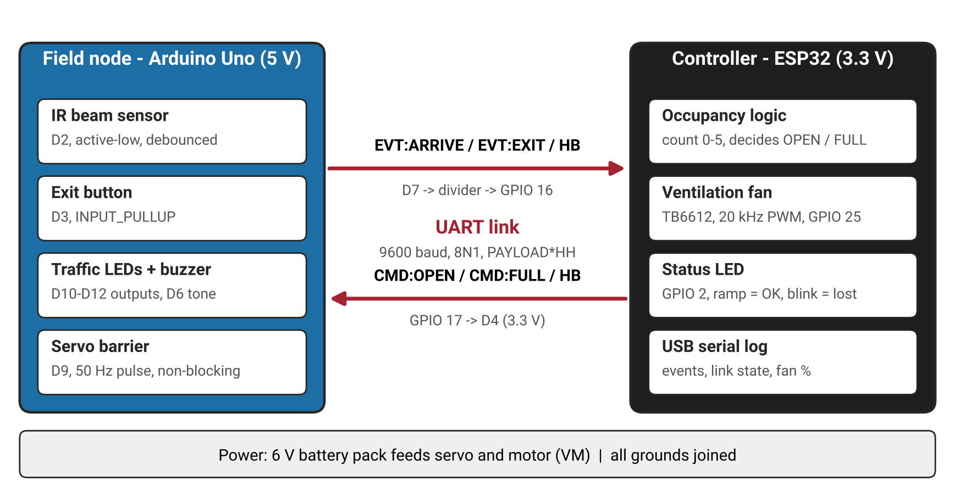
Figure 7.1: GateKeeper architecture: two nodes connected by one checksummed UART link.

7.3 Gate Behaviour and Fail-safe Design
The barrier is controlled by a four-state machine. A CMD:OPEN message starts the OPENING state; the barrier holds open for 3 seconds and closes only when the beam is clear. If no valid message arrives for 5 seconds, the link is declared lost: the barrier stays closed and the yellow light flashes, because showing green would invite cars in when the system cannot count them.
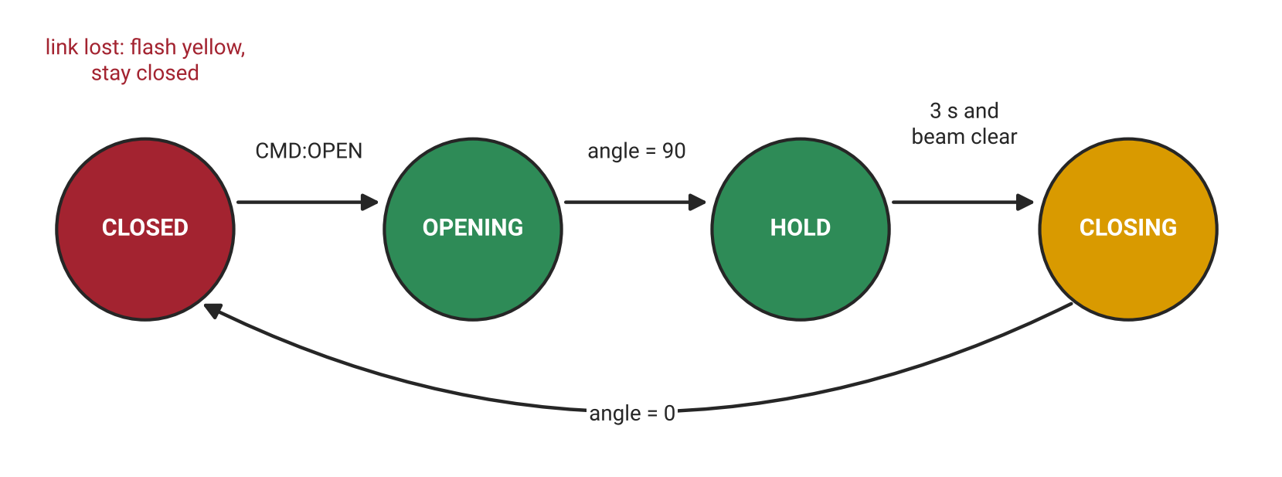
Figure 7.2: State machine of the gate barrier on the field node.

7.4 Final Pin Map
Node | Function | Pin
Uno field node | IR beam (car arrival), active-low | D2
Uno field node | Manual exit button to GND | D3
Uno field node | Link RX ← ESP32 TX | D4
Uno field node | Buzzer | D6
Uno field node | Link TX → divider → ESP32 RX | D7
Uno field node | Servo signal | D9
Uno field node | Red / yellow / green LEDs | D10 / D11 / D12
ESP32 controller | UART2 RX / TX | GPIO 16 / 17
ESP32 controller | Fan driver PWMA / AIN1 / AIN2 / STBY | GPIO 25 / 26 / 27 / 33
ESP32 controller | Status LED | GPIO 2

Lab Exercise 10: GateKeeper Integration, Testing and Documentation
Objective
To integrate Components A–D into a complete two-board smart parking gate, verify it against requirements R1–R8 with a structured test plan, and document it as a portfolio project.
Hardware Required
- Arduino Uno R3 and ESP32 DevKitC
- Traffic LEDs with resistors, buzzer, IR sensor, push button
- SG90 servo, DC motor, TB6612FNG driver
- 4 × AA battery pack, 1 kΩ and 2 kΩ resistors, breadboards and wires
- Multimeter and USB logic analyzer
Software Required
- Arduino IDE 2.x with Servo and ESP32Servo libraries
- PulseView
- Git and a GitHub account (for documentation)
Working Principle
The field node converts inputs into events (EVT:ARRIVE, EVT:EXIT), sends them over the checksummed link, and acts on commands from the controller. The controller keeps the occupancy count, replies CMD:OPEN or CMD:FULL, and sets the fan duty to 0% when empty, then 30% plus 70% × occupancy ÷ capacity. Both nodes send a heartbeat every 2 seconds and declare the link lost after 5 seconds of silence. Every part of the system is non-blocking, so sensing, communication and actuation run at the same time.
Procedure
- Create a project folder with sub-folders for field-node, controller, docs and captures, and initialise a Git repository.
- Integrate one component at a time in this order: link (D) → inputs (B) → lights (A) → barrier (C, Uno) → fan (C, ESP32) → fail-safes. Test and commit after each step.
- Upload the field-node sketch to the Uno and the controller sketch to the ESP32 (both include gk_protocol.h from Lab 9).
- Run the eight test cases in the test plan below and record the results.
- Capture three logic-analyzer screenshots: fan PWM, servo pulse and decoded UART traffic.
- Write a README containing the problem statement, a photo, the wiring diagram, the pin map, the protocol table, the test results and known limitations.
- Record a 2-minute demonstration video: problem (15 s), normal operation (60 s), link-failure test (30 s), lessons learned (15 s).
Program Code
Field node — Arduino Uno:
// GateKeeper field node v1.0 - Arduino Uno (uses gk_protocol.h)
#include <Servo.h>
#include <SoftwareSerial.h>
#include "gk_protocol.h"

const int BEAM_PIN = 2, BTN_PIN = 3, LINK_RX = 4, BUZZER = 6, LINK_TX = 7;
const int SERVO_PIN = 9, LED_R = 10, LED_Y = 11, LED_G = 12;

SoftwareSerial link(LINK_RX, LINK_TX);
Servo barrier;

enum GateState { CLOSED, OPENING, HOLD, CLOSING };
GateState gate = CLOSED;
int angle = 0;
unsigned long tStep = 0, tState = 0, tHbSent = 0, tLastRx = 0;
bool linkOk = false;

struct Input { int pin; int stable; int last; unsigned long tChange; };
Input beam = {BEAM_PIN, HIGH, HIGH, 0};
Input btn = {BTN_PIN, HIGH, HIGH, 0};

// Debounced falling-edge detector (active-low inputs)
bool fell(Input &in, unsigned long debounceMs) {
int r = digitalRead(in.pin);
if (r != in.last) { in.last = r; in.tChange = millis(); }
if (millis() - in.tChange > debounceMs && r != in.stable) {
in.stable = r;
return r == LOW;
}
return false;
}

void lights(bool r, bool y, bool g) {
digitalWrite(LED_R, r); digitalWrite(LED_Y, y); digitalWrite(LED_G, g);
}

void handleCommand(const char *msg) {
if (strcmp(msg, "CMD:OPEN") == 0 && gate == CLOSED) { gate = OPENING; lights(LOW, LOW, HIGH); }
else if (strcmp(msg, "CMD:FULL") == 0) tone(BUZZER, 1000, 300);
// HB:1 needs no action: receiving it already refreshed tLastRx
}

void setup() {
pinMode(BEAM_PIN, INPUT_PULLUP);
pinMode(BTN_PIN, INPUT_PULLUP);
pinMode(LED_R, OUTPUT); pinMode(LED_Y, OUTPUT); pinMode(LED_G, OUTPUT);
Serial.begin(115200); // USB debug log
link.begin(9600); // link to controller
barrier.attach(SERVO_PIN);
barrier.write(0);
lights(HIGH, LOW, LOW);
Serial.println(F("GateKeeper field node ready"));
}

void loop() {
unsigned long now = millis();

// 1. Inputs -> events
if (fell(beam, 50)) { sendMsg(link, "EVT:ARRIVE"); Serial.println(F("TX EVT:ARRIVE")); }
if (fell(btn, 30)) { sendMsg(link, "EVT:EXIT"); Serial.println(F("TX EVT:EXIT")); }

// 2. Receive and validate
if (readLine(link)) {
if (validMsg(line)) {
tLastRx = now;
if (!linkOk) Serial.println(F("LINK UP"));
linkOk = true;
handleCommand(line);
} else {
Serial.println(F("RX bad checksum"));
}
}

// 3. Heartbeat out, 4. link watchdog
if (now - tHbSent >= 2000) { tHbSent = now; sendMsg(link, "HB:1"); }
if (linkOk && now - tLastRx > 5000) { linkOk = false; Serial.println(F("LINK LOST")); }

// 5. Gate state machine (non-blocking servo)
switch (gate) {
case OPENING:
if (now - tStep >= 15) {
tStep = now; barrier.write(++angle);
if (angle >= 90) { gate = HOLD; tState = now; }
}
break;
case HOLD: // never close on a car
if (now - tState >= 3000 && beam.stable == HIGH) { gate = CLOSING; lights(LOW, HIGH, LOW); }
break;
case CLOSING:
if (now - tStep >= 15) {
tStep = now; barrier.write(--angle);
if (angle <= 0) gate = CLOSED;
}
break;
case CLOSED: // fail-safe display
if (!linkOk) lights(LOW, (now / 500) % 2, LOW);
else lights(HIGH, LOW, LOW);
break;
}
}

Controller — ESP32:
// GateKeeper controller v1.0 - ESP32 DevKitC, Arduino-ESP32 core 3.x
#include "gk_protocol.h"

const int RX2 = 16, TX2 = 17;
const int FAN_PWM = 25, FAN_IN1 = 26, FAN_IN2 = 27, FAN_STBY = 33;
const int STATUS_LED = 2;
const int CAPACITY = 5;

int occupied = 0;
unsigned long tHb = 0, tLastRx = 0;
bool linkOk = false;

void updateFan() {
// ventilation scales with occupancy (30% floor so the motor starts)
int pct = (occupied == 0) ? 0 : 30 + (70 * occupied) / CAPACITY;
ledcWrite(FAN_PWM, map(pct, 0, 100, 0, 255));
Serial.printf("occupied=%d/%d fan=%d%%\n", occupied, CAPACITY, pct);
}

void handleEvent(const char *msg) {
if (strcmp(msg, "EVT:ARRIVE") == 0) {
if (occupied < CAPACITY) { occupied++; sendMsg(Serial2, "CMD:OPEN"); }
else { sendMsg(Serial2, "CMD:FULL"); Serial.println("FULL"); }
} else if (strcmp(msg, "EVT:EXIT") == 0) {
if (occupied > 0) occupied--;
sendMsg(Serial2, "CMD:OPEN");
} else {
return; // heartbeat: nothing to do
}
updateFan();
}

void setup() {
Serial.begin(115200);
Serial2.begin(9600, SERIAL_8N1, RX2, TX2);
pinMode(FAN_IN1, OUTPUT); pinMode(FAN_IN2, OUTPUT); pinMode(FAN_STBY, OUTPUT);
digitalWrite(FAN_IN1, HIGH); digitalWrite(FAN_IN2, LOW); // one direction only
digitalWrite(FAN_STBY, HIGH);
ledcAttach(FAN_PWM, 20000, 8); // 20 kHz silent fan PWM
ledcAttach(STATUS_LED, 5000, 8);
updateFan();
Serial.println("GateKeeper controller ready");
}

void loop() {
unsigned long now = millis();

if (readLine(Serial2)) {
if (validMsg(line)) {
tLastRx = now;
if (!linkOk) Serial.println("LINK UP");
linkOk = true;
handleEvent(line);
} else {
Serial.println("RX bad checksum");
}
}

if (now - tHb >= 2000) { tHb = now; sendMsg(Serial2, "HB:1"); }
if (linkOk && now - tLastRx > 5000) { linkOk = false; Serial.println("LINK LOST"); }

// Status LED: smooth ramp = link OK, fast blink = link lost
if (linkOk) ledcWrite(STATUS_LED, (now / 8) % 256);
else ledcWrite(STATUS_LED, ((now / 150) % 2) ? 255 : 0);
}

Test Plan
Test | Req. | Steps | Expected result
TC1 | R1–R3 | Break the beam with spaces free | CMD:OPEN, light GREEN, barrier opens, count +1
TC2 | R2 | Break the beam a 6th time | CMD:FULL, beep, barrier stays closed
TC3 | R4 | Keep the beam broken during the hold time | Barrier stays open until the beam clears
TC4 | R5 | Step occupancy from 0 to 5 | Fan duty 0, 44, 58, 72, 86, 100%
TC5 | R6 | Send a message with a wrong checksum | Rejected and logged, no action
TC6 | R7 | Unplug the link wire | Both nodes log LINK LOST within 5 s; yellow flashes
TC7 | R7 | Reconnect the link wire | LINK UP; normal operation resumes
TC8 | R8 | 30-minute run with 50 cycles | No missed or double counts; full log saved

Expected Output
Cars (simulated with a hand or card) are counted on arrival; the barrier opens smoothly with a green light when space is free and the buzzer sounds when the car park is full. The fan speed rises with occupancy, and both Serial Monitors log every event. Disconnecting the link makes both nodes report LINK LOST and the gate flashes yellow while staying closed; reconnecting restores normal operation.
Observation
Record what you measure and see while running the experiment. Fill in the table below and attach screenshots of the Serial Monitor (and logic-analyzer captures where asked).
# | What to observe | Your observation
1 | Result (pass / fail) of each test case TC1–TC8
2 | Measured fan duty at each occupancy level
3 | Time from unplugging the link to LINK LOST on each node
4 | Any faults found during integration and how they were fixed

Outcome
The learner produces a working, tested and documented two-board embedded system with a public repository, wiring diagram, protocol specification, test log, signal captures and demonstration video — clear evidence of practical embedded-systems skill.
Conclusion
This project brings together every topic in the module: architecture-based board selection, safe digital outputs, reliable digital inputs, PWM control of two kinds of actuator, and verified UART communication. Integrating them step by step, testing against requirements, and designing for failure are the same practices used by professional embedded engineers.

Review Questions
- What are the three parts of the I-P-O model? Describe a TV remote control in these terms.
- Which memory loses its contents at reset: flash or SRAM? What does the F() macro save on the Uno?
- Give two reasons why the ESP32 was chosen as the GateKeeper controller rather than the field node.
- Calculate the series resistor for a green LED (2.2 V) at 10 mA on a 5 V pin.
- Why must millis() timestamps be stored in unsigned long variables?
- With INPUT_PULLUP, what does an unpressed button read, and which edge marks a press?
- Why must a variable shared between an ISR and loop() be declared volatile?
- What average voltage does a 3.3 V ESP32 pin give at 10-bit duty 300?
- What pulse width commands a servo to about 90°, and at what frequency are the pulses repeated?
- How many bits are sent on the wire for one byte in 8N1 format, and how long does one bit last at 115200 baud?
- Why does the Uno's TX line need a voltage divider when connected to the ESP32?
- What does a checksum detect, and what does it not do?

